Gitops <https://dev.to/mxoliver/learning-gitops-with-helm-charts-flux-163m>

=====================

<https://github.com/mmumshad/kubernetes-training-answers>

<https://github.com/mmumshad/kubernetes-example-voting-app.git>

Pod related: <https://kodekloud.com/p/public-labs?scenario=kubernetes-for-beginners-pods-new>

For hands on - <https://www.katacoda.com/courses/kubernetes/>(very important)

<https://www.cncf.io/wp-content/uploads/2019/07/The-Illustrated-Childrens-Guide-to-Kubernetes.pdf>

Eks: <https://cisco.udemy.com/course/amazon-eks-starter-kubernetes-on-aws/>

<http://www.yamllint.com/>

Credential manager

Youtube

<https://www.youtube.com/channel/UCuFg53ZTr6maqBC-4i9o4-w/playlists>

<https://www.youtube.com/user/wenkatn/playlists>

image

<https://www.youtube.com/watch?v=KlggT7ZjKOw>

Study material : <https://github.com/lucassha/CKAD-resources>

Node, replicaset,deployment,services

NOTE:

Taint are set on node and toleration set on pods

Nodeaffinity: place the pod on large node

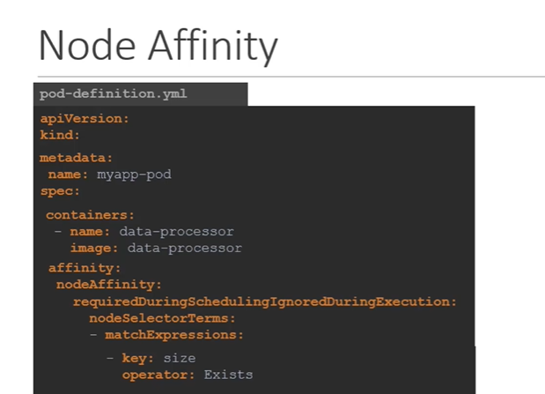

=======================================================================================

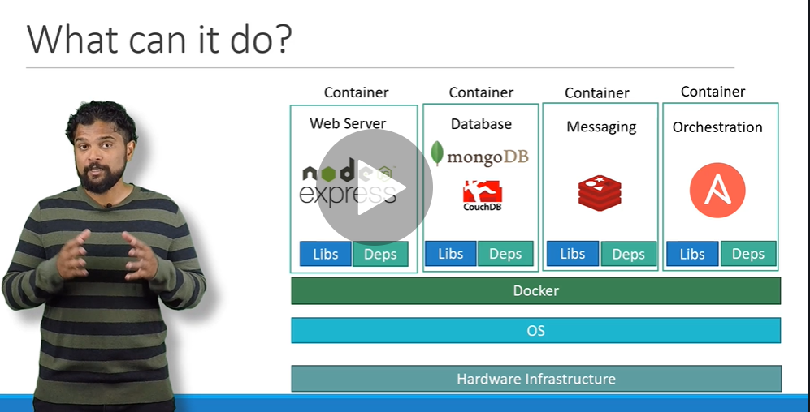

Note :

Docker manage container and libraries etc

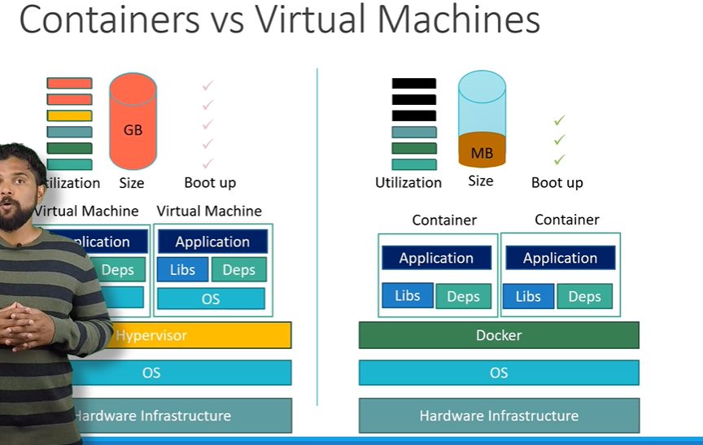

Container are running instance of image

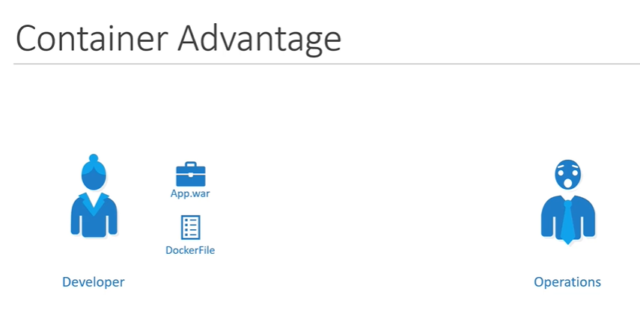

Image contain dockerfile +app.war

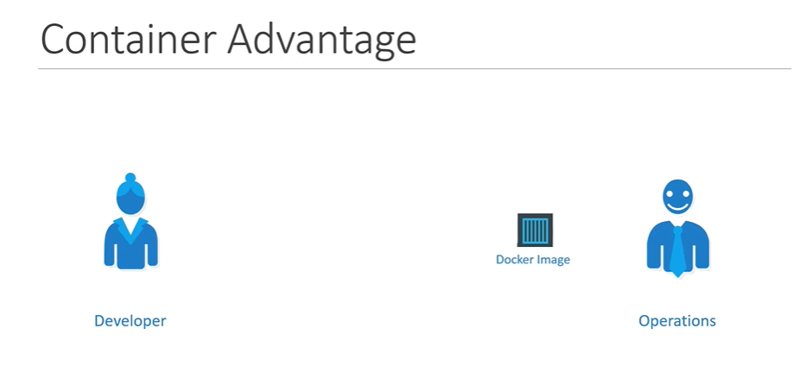

Managing container is known as container orchestration

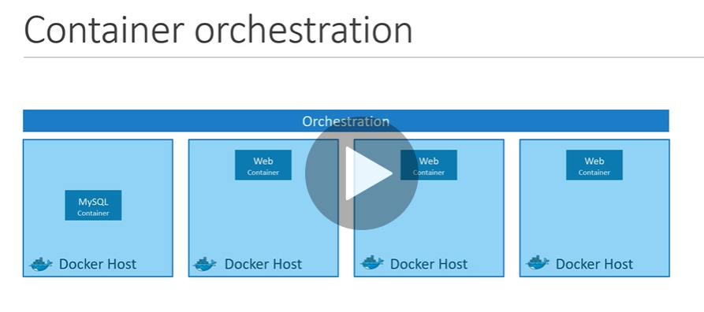

Kubernetes is container orchestration technology that use to orchestrate deployment and management of container in cluster

=============================

Node : is a physical or virtual machine on which kubernetes is installed

Node : is a worker machine and that is where container will be launch by kubernetes

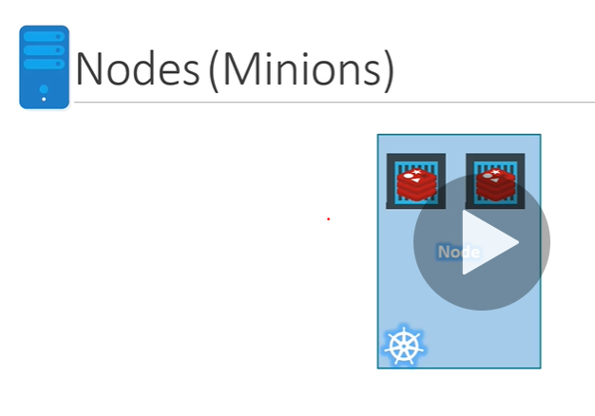

Query : what will happen if application running on node is failed . That’s why we need more node

Cluster : is a set of node group together. If one node is failed other is accessible.

Query : who is responsible to managing a cluster

If a node failed how workload is managing among other node

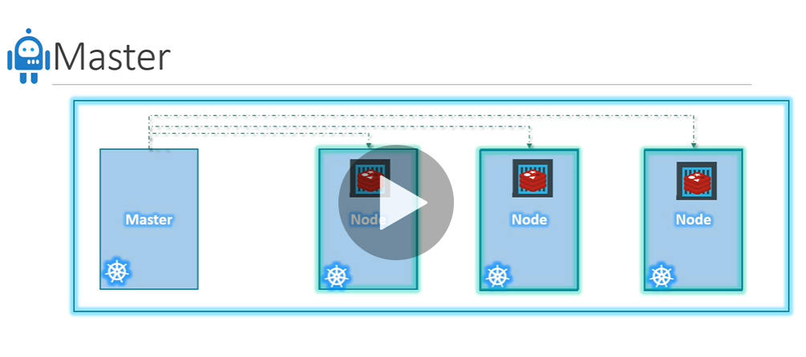

Master node is actual responsible for orchestration of container in worker node

A **master node** is a **node** which controls and manages a set of worker **nodes** (workloads runtime) and resembles a cluster in **Kubernetes**

**Note :**

When we install kubernetes on system we actually install following components

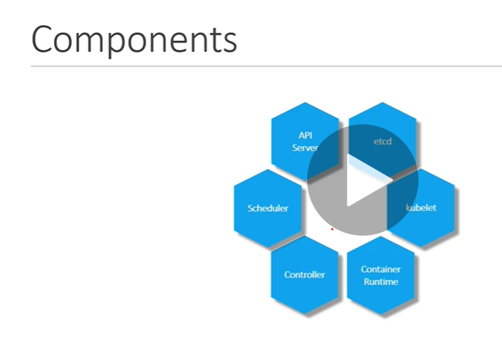

Api server act as frontend for kubernetes ( users , command line interface)

Etcd : key value store use by kubernetes to store all data use by cluster.

example: store node and master info

**etcd** is a consistent and highly-available key value store used as **Kubernetes**' backing store for all cluster data.

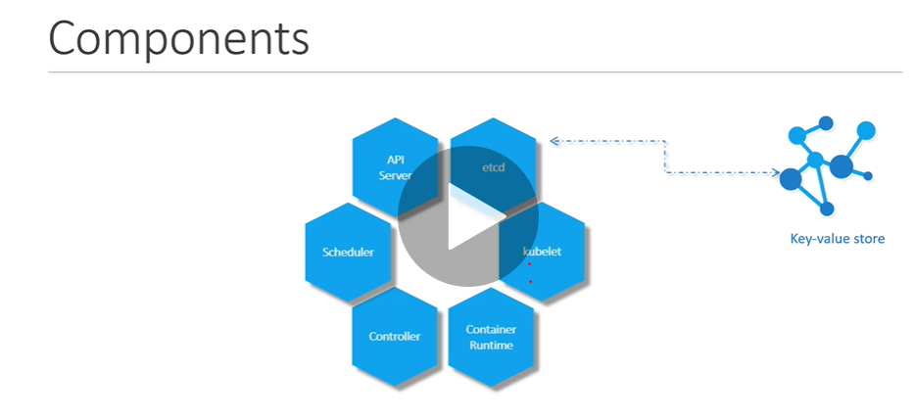

Scheduler:

Is responsible for distributed work across node in cluster.

It look for newly created container and assigned the task

Controller : are responsible for when one node goes down new node will come up

Container runtime : is underlying sw is use to run container. In our case it is docker but there are other option

Kubelet : is agent that run run on each node of cluster. Agent is responsible for that container is running on each node as expected

**kubelet**. An agent that runs on each node in the cluster. It makes sure that containers are running in a pod

A **Pod** always runs on a **Node**. A **Node** is a worker machine in **Kubernetes** and may be either a virtual or a physical machine, depending on the cluster. ... A **Node** can have multiple **pods**, and the **Kubernetes** master automatically handles scheduling the **pods** across the **Nodes in the** cluster

Docker : container runtime engine

Master node have kube-api server and that what make it master and similarly worker node have kubelet agent that is responsible to interact with master to get health info of worker node . All the info gathered that are stored in key value pair in etcd in master

V imp

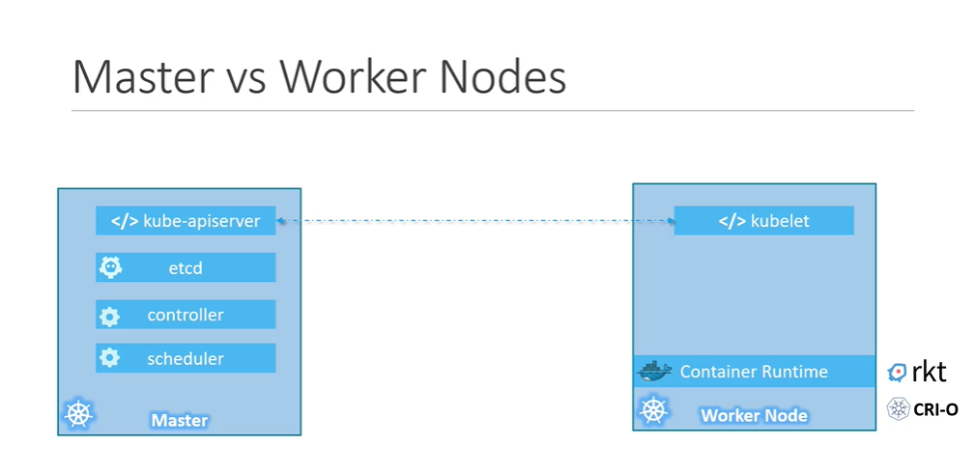

Kubectl :

Is a tool use to deploy and manage application on kubernetes cluster

**kubectl** controls the **Kubernetes** cluster manager.

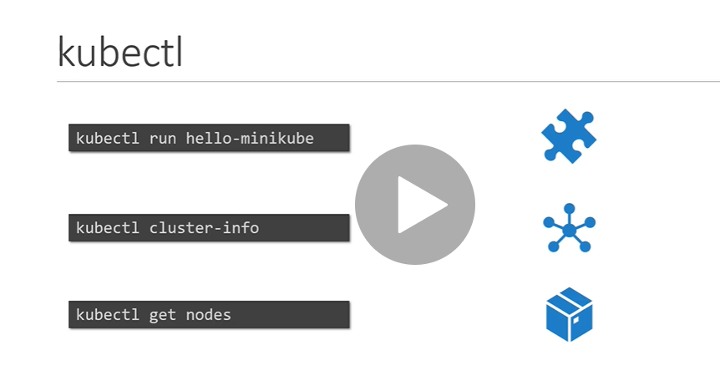

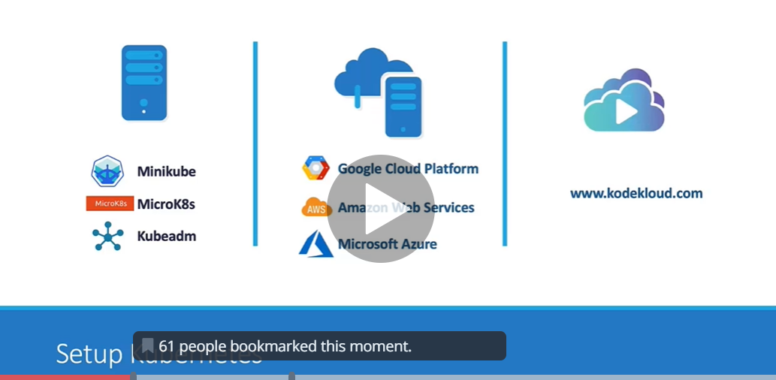

Minikube bundled all different component into a single image ( single node kubernetes cluster)

It availabl

e online as iso image

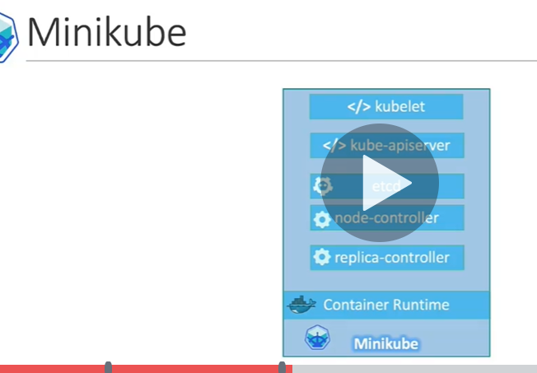

Need three things to installed:

Hypervisor

Kubectl

Minikube

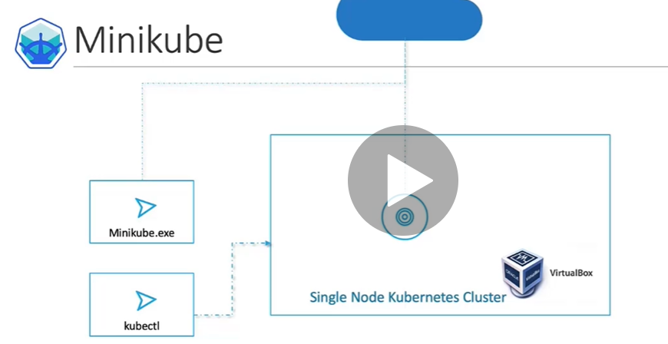

How many nodes part of cluster:

Kubectl get nodes

===================================

Install MiniKube: <https://kubernetes.io/docs/tasks/tools/install-minikube/>

VirtualBox: <https://www.virtualbox.org/wiki/Downloads>

MiniKube Download page for  Windows: <https://github.com/kubernetes/minikube/releases>

While using Minikube with  Virtualization technologies other than virtualbox, specify the --vm-driver option like this:

* 1. minikube start --vm-driver=<driver_name>

More about it here: <https://kubernetes.io/docs/setup/learning-environment/minikube/#specifying-the-vm-driver>

**Minikube** is a tool that makes it easy to run **Kubernetes** locally. **Minikube** runs a single-node **Kubernetes** cluster inside a Virtual Machine (VM) on your laptop for users looking to try out **Kubernetes** or develop with it day-to-day.

==================================================================

Note : pods is basically a container

Difference between pod and node:-

A **Pod** always runs on a **Node**. A **Node** is a **worker** machine in Kubernetes and may be either a virtual or a physical machine, depending on the cluster. Each **Node** is managed by the Master. A **Node** can have multiple **pods**, and the Kubernetes master automatically handles scheduling the **pods** across the **Nodes in the** cluster.

**Container are encapsulated into a kubernetes object known as pods**

A pod is single instance of object or pod is smallest object create in kubernetes

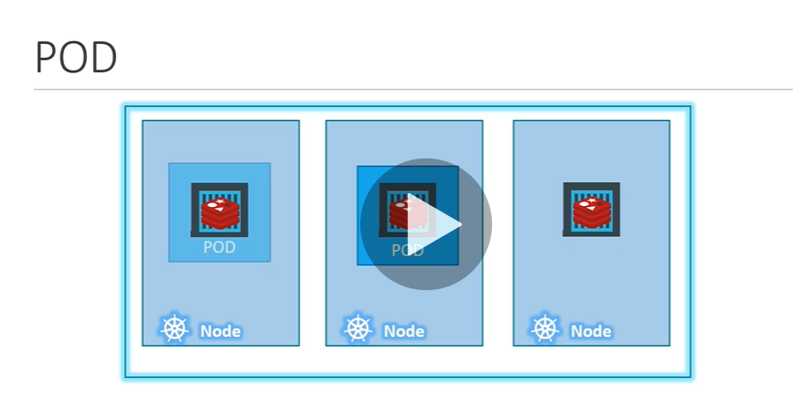

Important: **pod is one to one r/s with container**

To scale up we create new pod and to scale down we delete additional pod

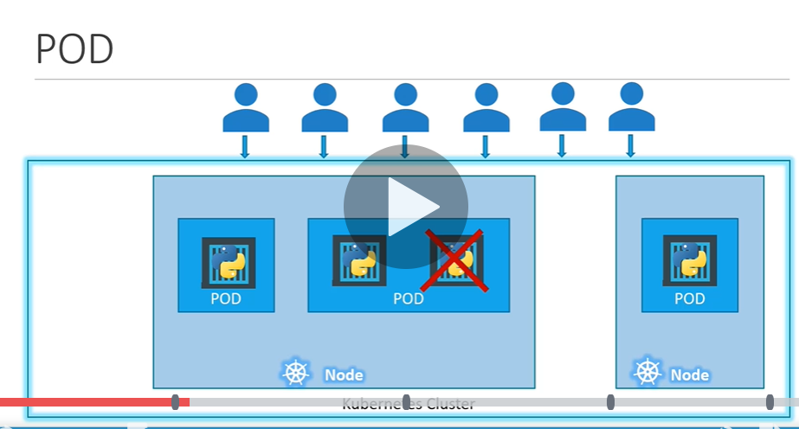

**Query:**

How we implement load balancer between the container

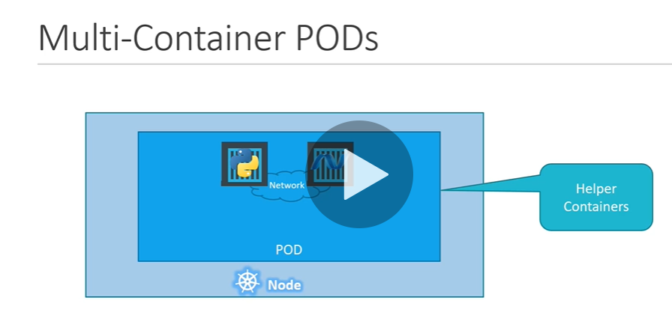

Note: each pod has it internal ip address

<https://kubernetes.io/docs/concepts/workloads/pods/pod-overview/>

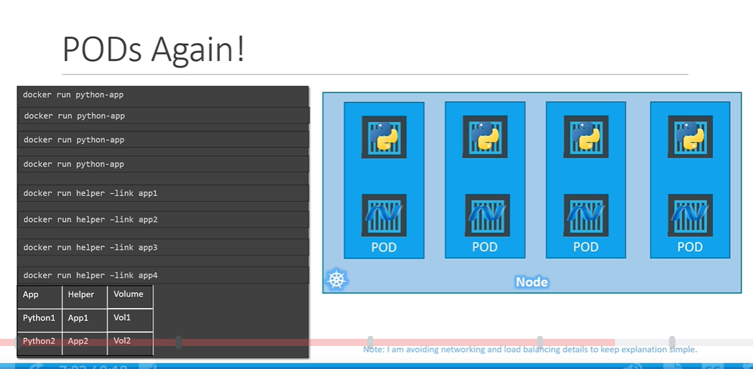

Kubernetes create helper container for us

Kubectl: it deploy a docker container by creating a pod

Note: we just see how to deploy a image in later lecture we will see how service will be accessible to the end user ( once we learn networking and service)

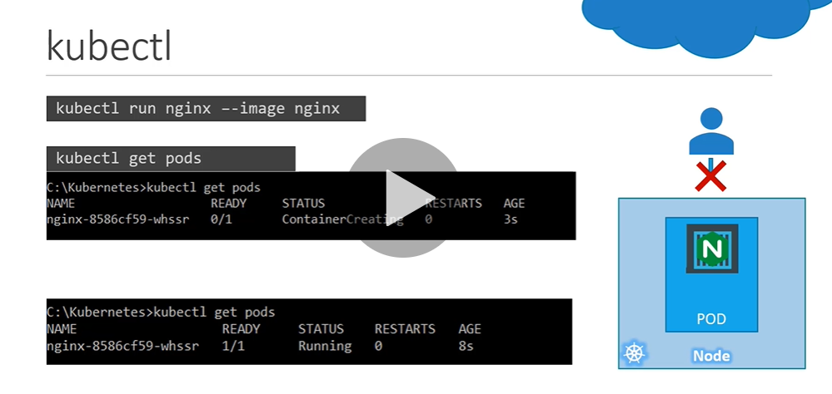

Yaml:

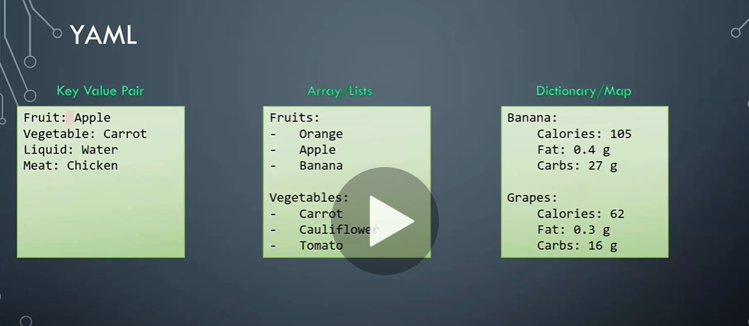

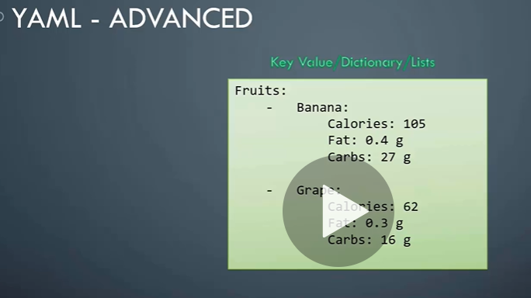

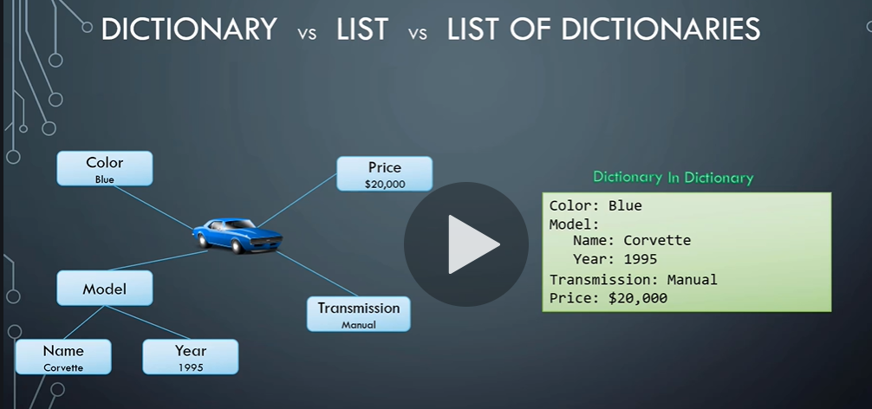

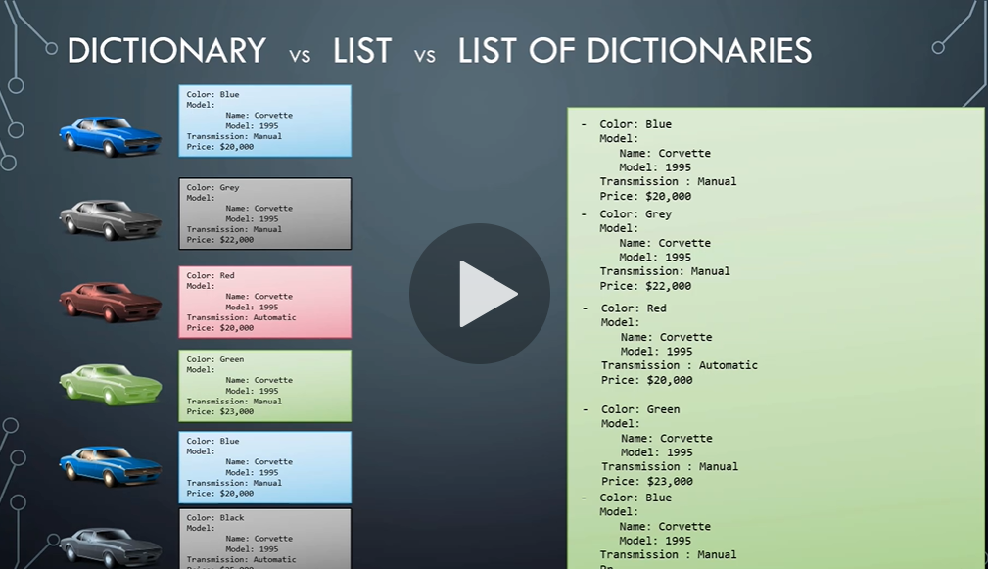

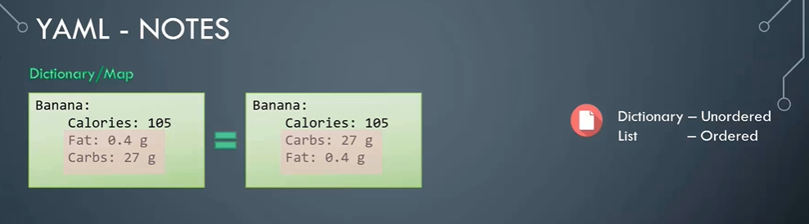

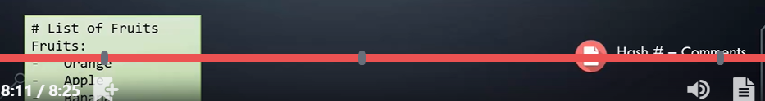

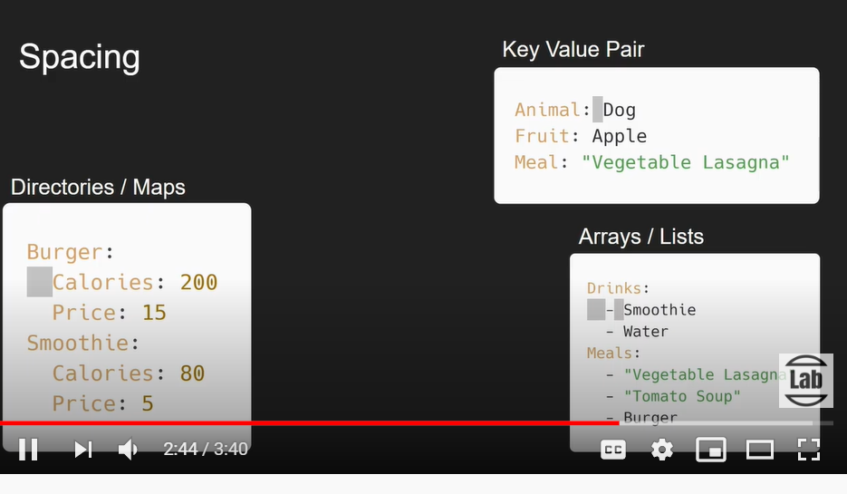

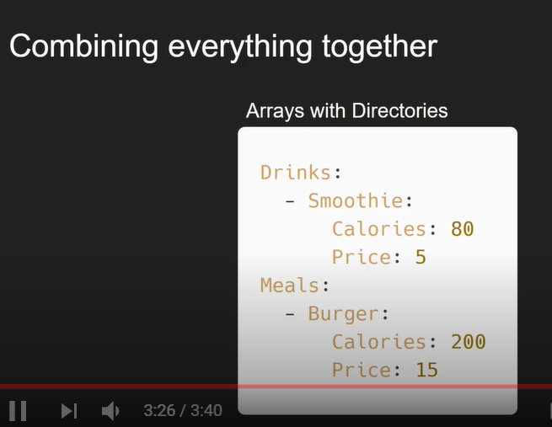

=================================================================================

**Yaml in kubernetes**

**Notes:** Kubernetes uses yaml file as input for the creation of object such as pods, replica, deployments and services

Root level properties( total 4 are there)

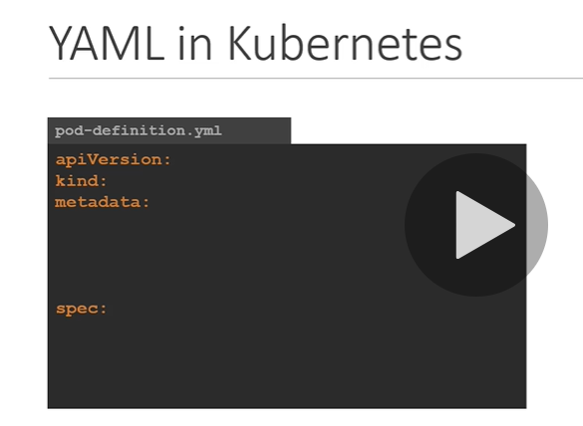

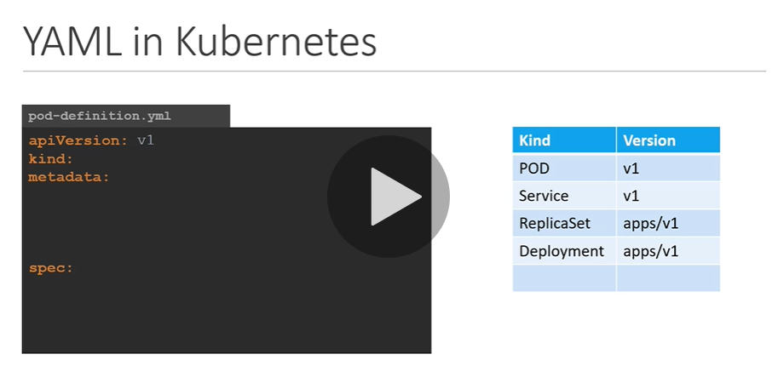

Note : everything under metadata is in form of dictionary

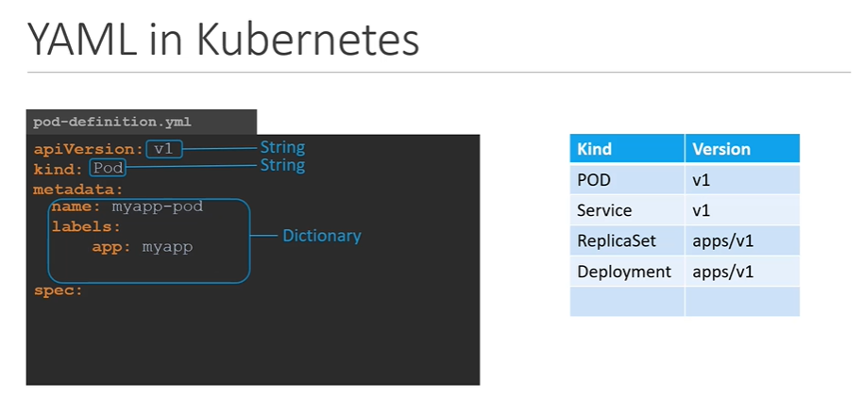

We define name of pod and label under metadata

And last section will tell about image which we want in pod

Note: spec is going to be different for different object

Note: we are creating a pod with single container in it( so it is easy)

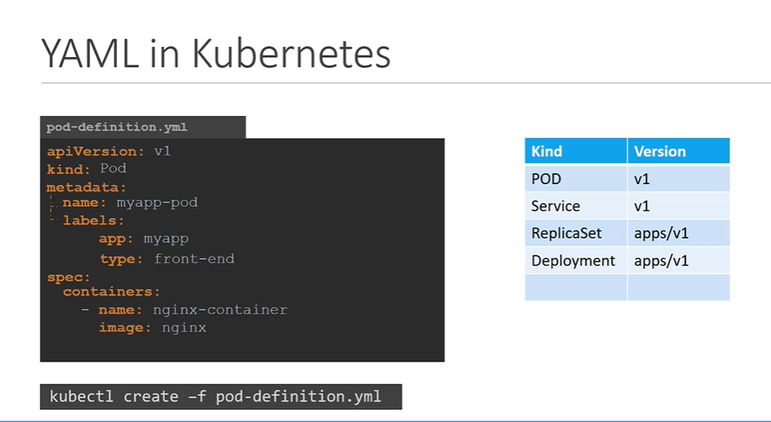

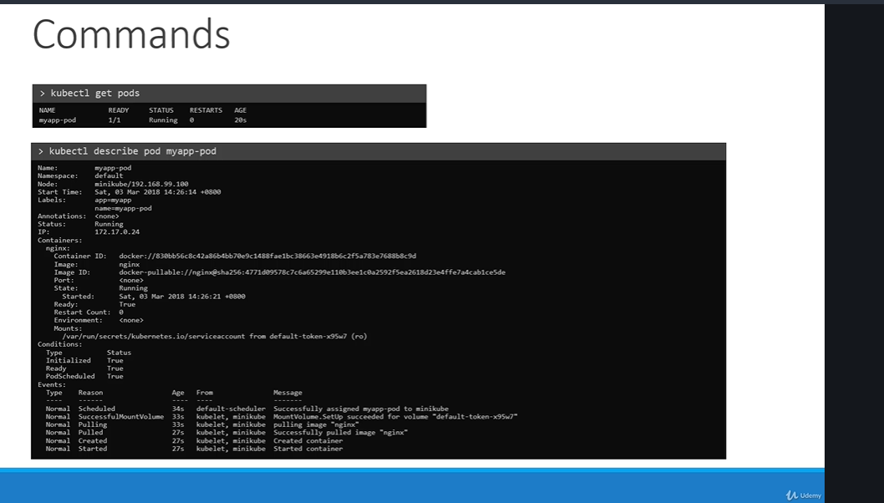

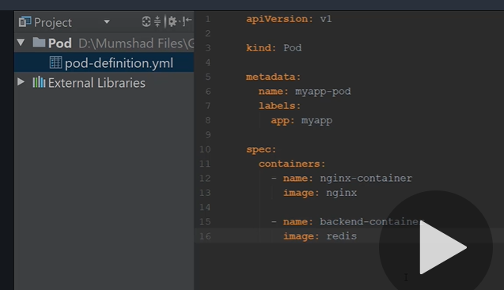

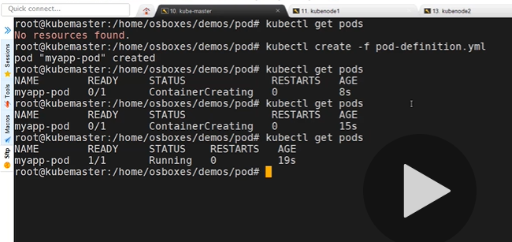

apiVersion: v1

kind: Pod

metadata:

name: postgres

labels:

tier: db-tier

spec:

containers:

- name: postgres

image: postgres

Spec: define what inside the object we are creating

**Replication Controller:-**

Help us to run multiple instance of single pod in the kubernetes cluster

---ensure specify number of pod is running all time even one or 100 pod is there

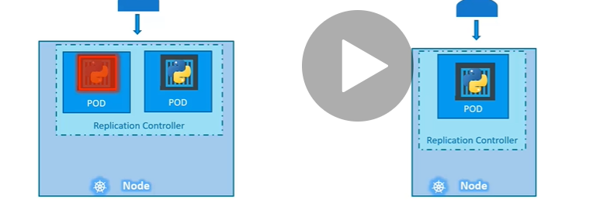

It help in load balancing and scaling when user increases:

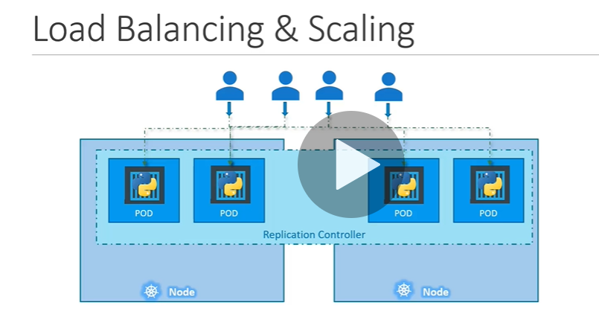

**NOTE:**

Replication controller is the older technology that is replaced by replica set

Important: replication controller

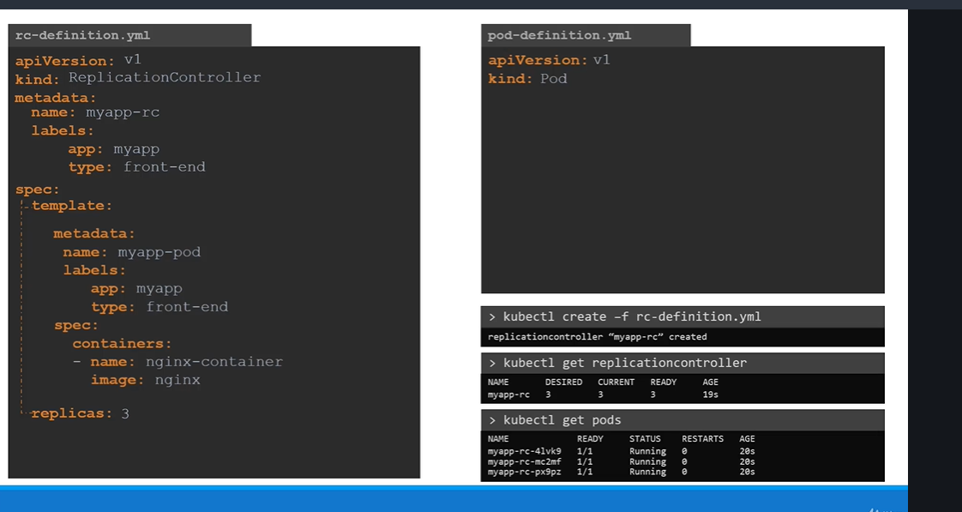

Replica Set

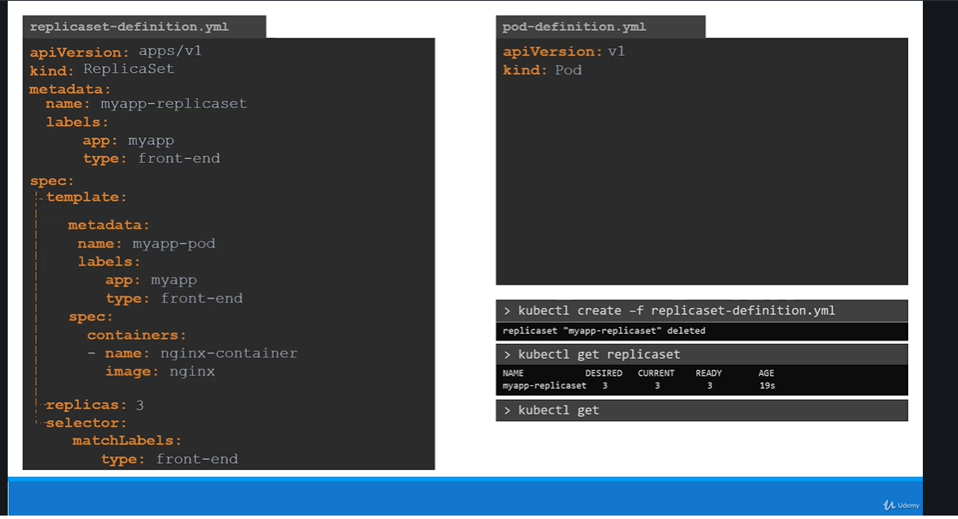

Major difference is selector

**NOTE : selector use to link the replica set with pod**

Note:

Replica set is a process that monitors the pod.

How replica set will know which pods need to monitor this is where labelling come into handy.

We can provide label to replica set that we gave same label while creating pod this way replica set will know which pod need to monitor

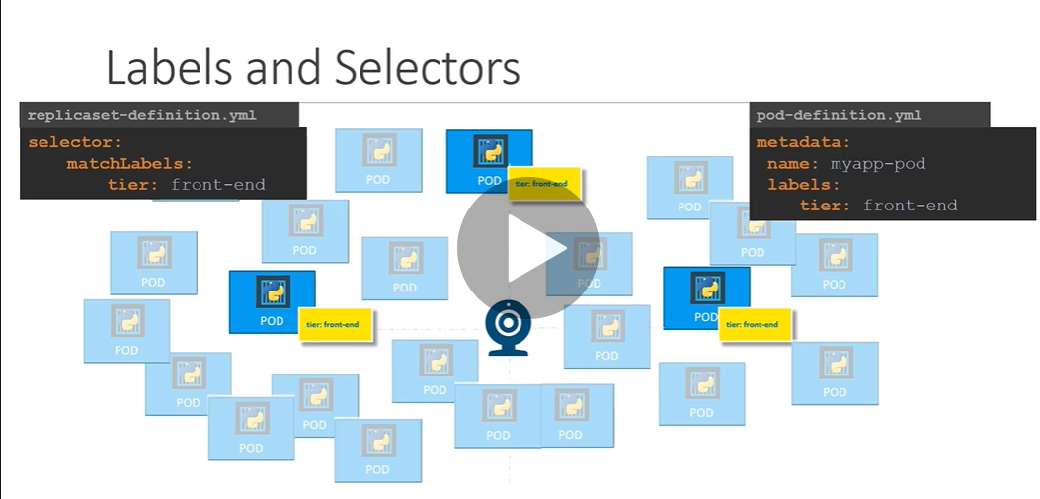

How to scale replica set

Note : 3rd one is not correct

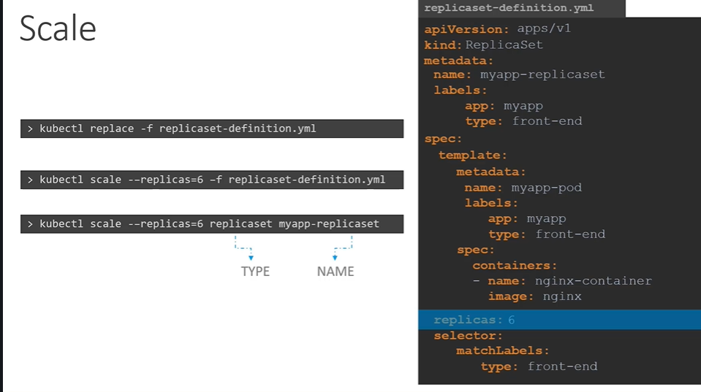

Replicaset command

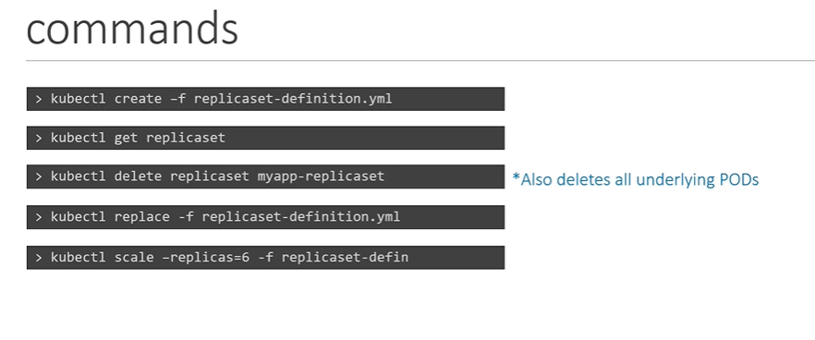

Deployment.yaml

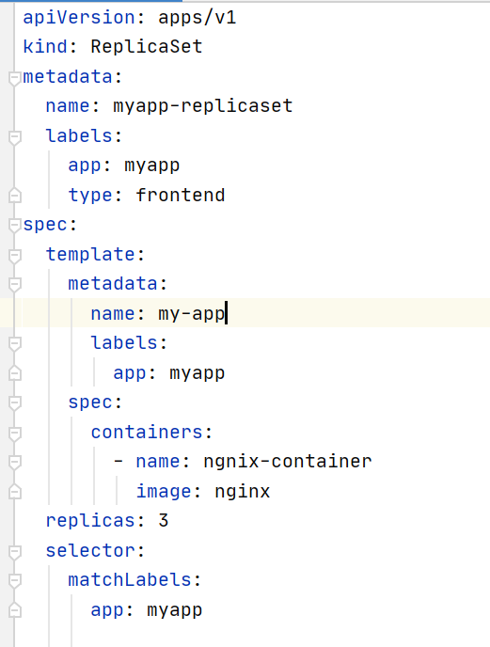

Kubectl create -f deployment.yaml

Kubectl get replicaset

Kubectl describe replicaset

Kubectl get pods ( three replica set will get created)

**Note: replicaset use to monitor the pod and if one of the pod is deleted replicaset use to create new pod**

kubectl delete pod myapp-replicaset-thhrt

**NOTE: replica set will not allow to create pod with same label**

kubectl get pods -o wide ( will give info about node)

**If we updata replicaset**

kubectl replace -f deployment.yaml

**We can down replica set**

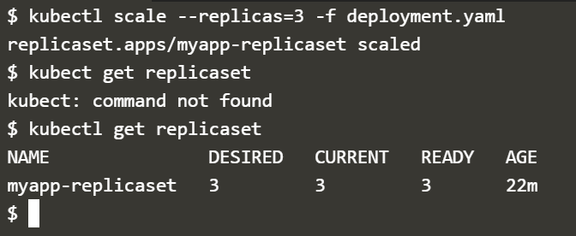

Kubectl delete replicaset myapp-replicaset

===============================

Deployment:

Want to upgrade instance or undo changes

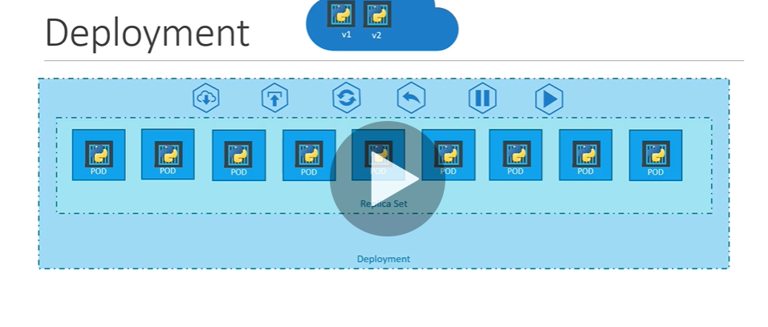

The content of deployment is exactly same as replica set except kind

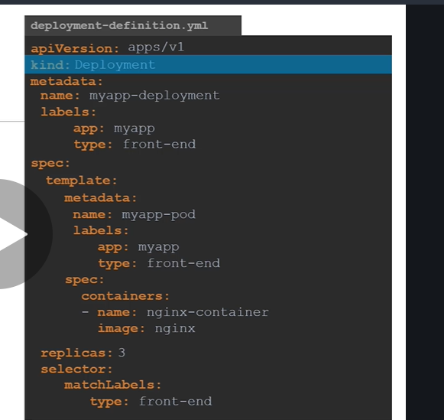

Note: template has pod definition inside it

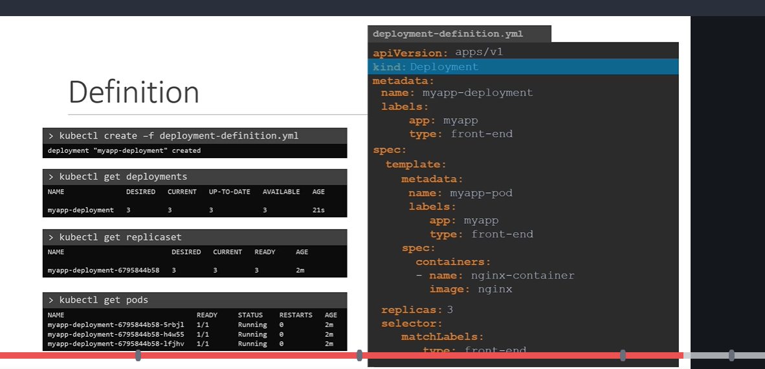

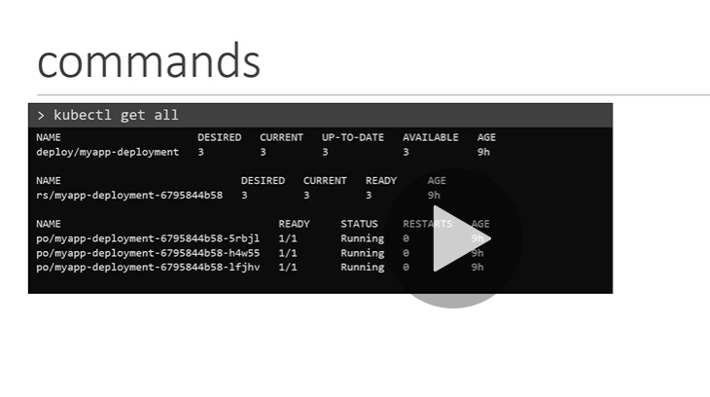

Deployment update and rollback

. A **Deployment** runs multiple replicas of your application and automatically replaces any instances that fail or become unresponsive. ... **Deployments** are managed by the **Kubernetes Deployment** controller

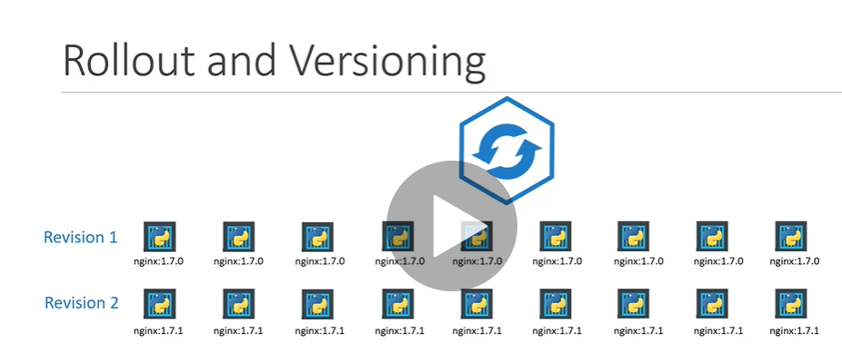

Whenever image or container version is update new revision will create and in this way it will maintain version

Kubectl rollout command

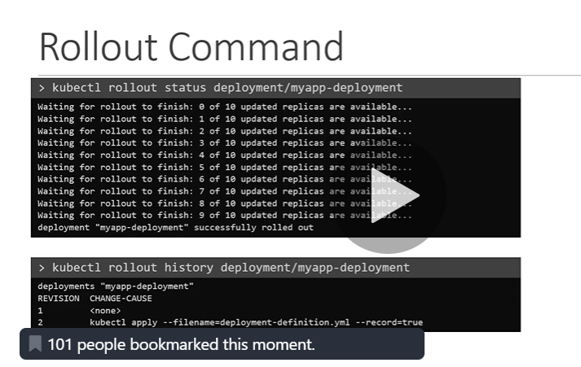

Rollout is the process of deploying container in the background as soon as we create deployment

**NOTE: there are two ways of deployment strategy:**

1)**recreate** : one way to upgrade newer versionis to destroy all instance then create instance again but in this strategy application is down

2)**rolling update** : destroy one instance then upgrade it( one by one) means downgrade the older version and bring the newer version one by one

Note: rolling update is default deployment strategy

Note: as soon as deployment is created , it creates a new rollout

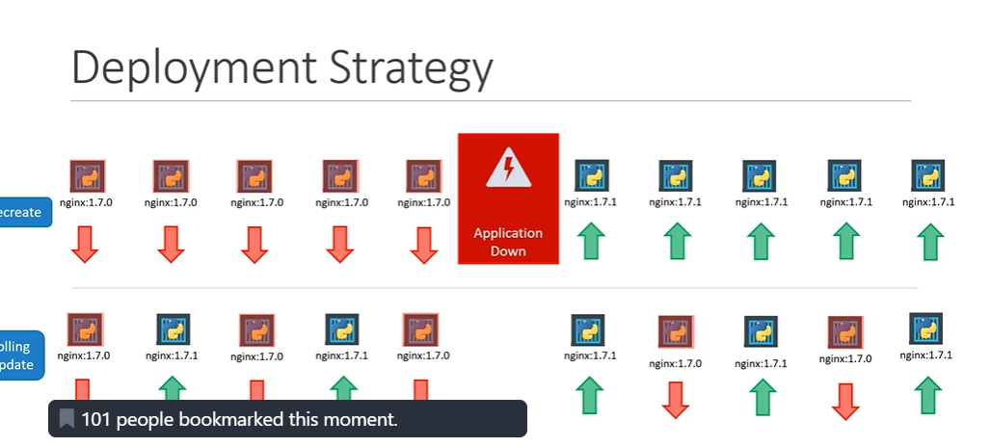

Update

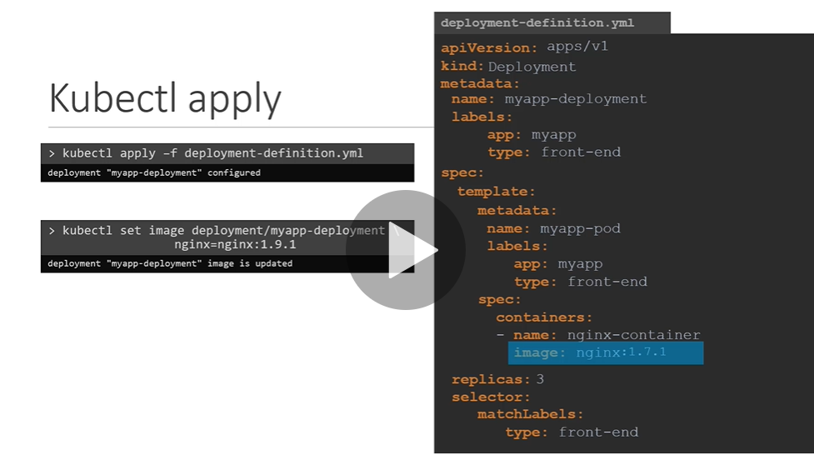

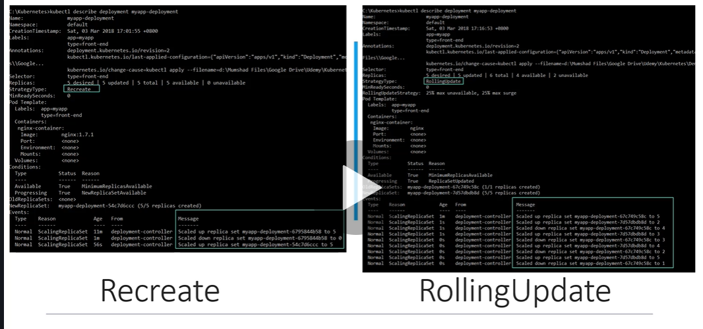

NOTE: in recreate all replicaset scaled down one at a time and scale up one at a time

in rollingupdate replicaset scaled up or down one a time

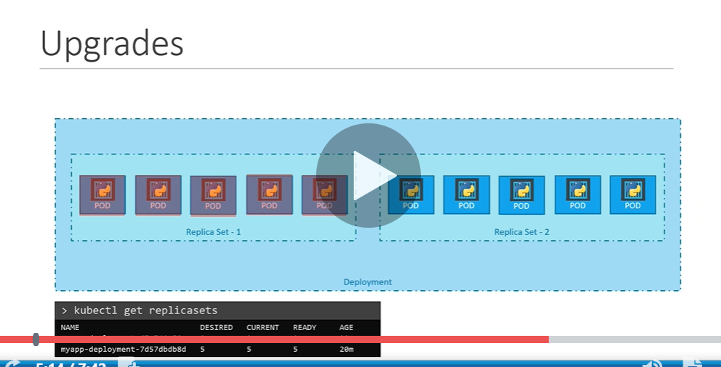

Whenever upgrades occur new replicaset object will create

Note: suppose after upgrade something wrong so kubernates deployment to rollback or undo changes

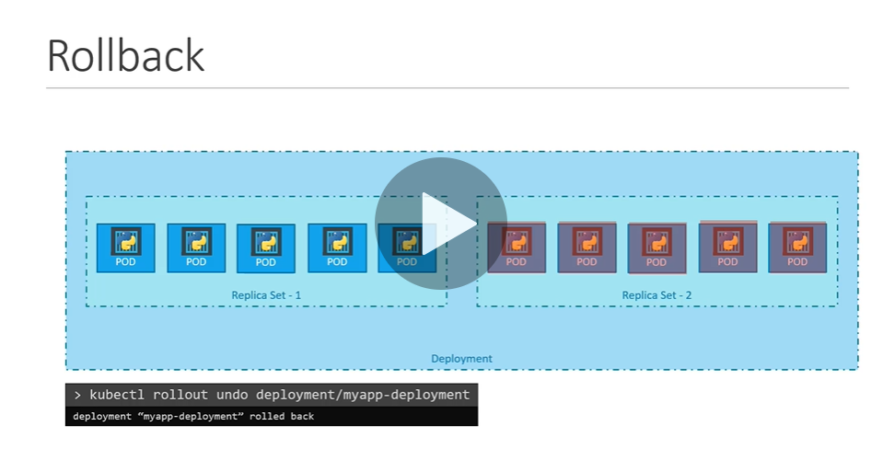

Then it destroy pod in new replicaset and bring up pod in older replicaset

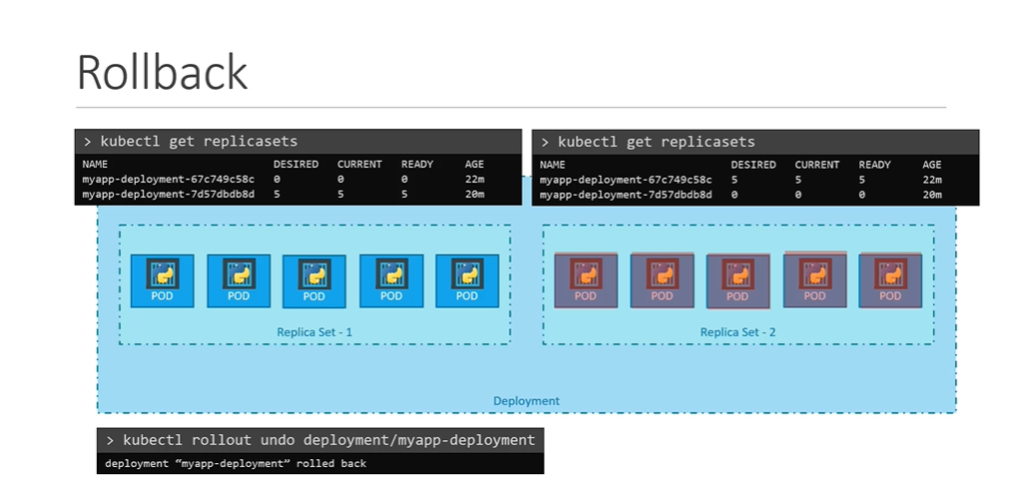

// note: will create deployment directly

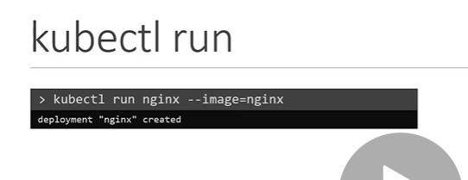

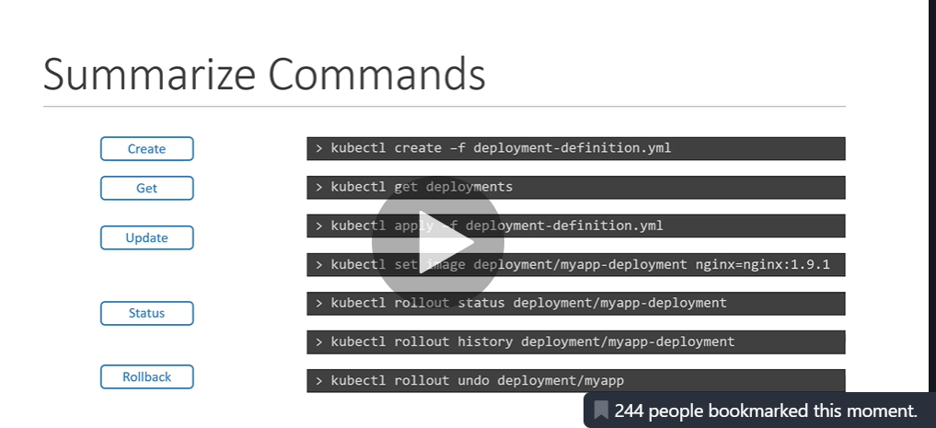

Kubernetes networking

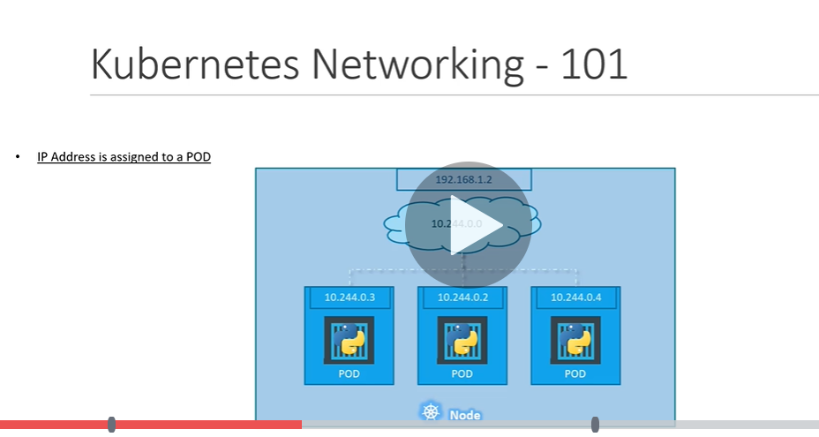

Internal ip assigned to pod since kubernete configure internal private network but if pod recreate ip address will gone so this is not a good way

Note: pod communicate with each other through internal networking

**One problem**

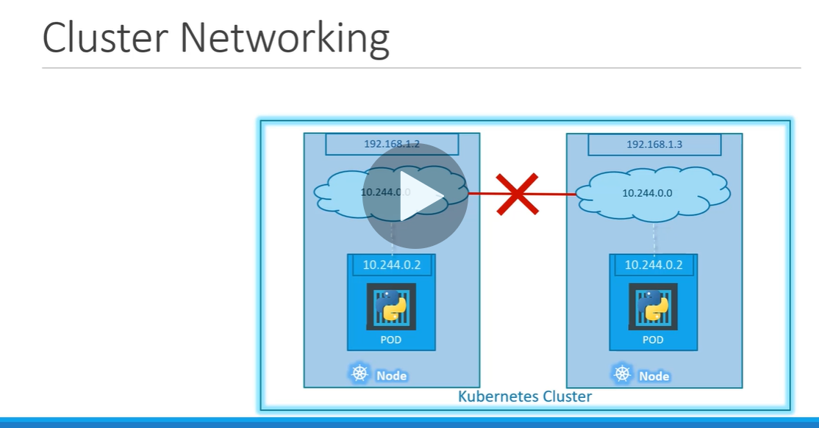

Same address assigned to pod by internal private network and conflict in ip will occur

Solution

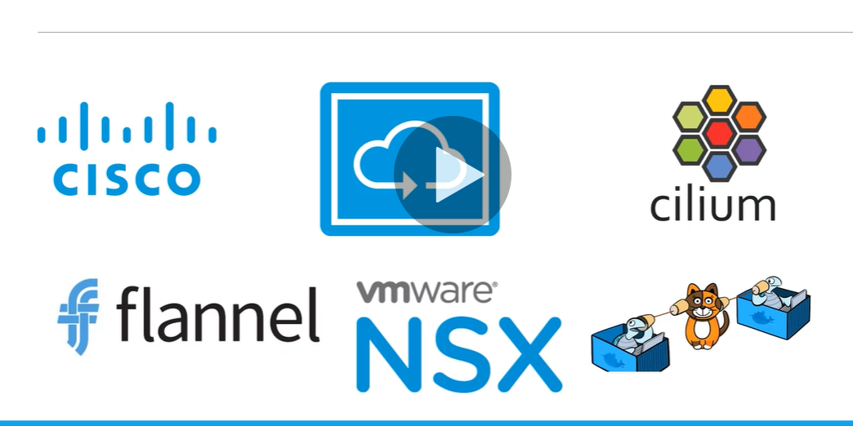

**flannel** is a virtual network that gives a subnet to each host for use with container runtimes. Platforms like Google's **Kubernetes** assume that each container (pod) has a unique, routable IP inside the cluster. The advantage of this model is that it reduces the complexity of doing port mapping.

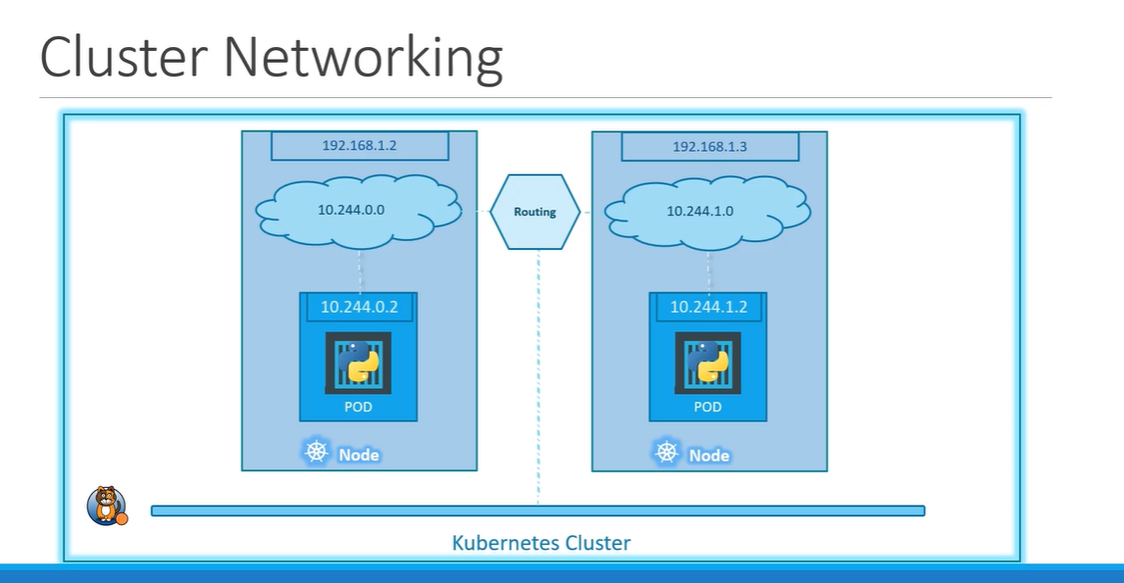

================

**Kubernetes service**: enable communication between various component within and outside of the application

**Notes:** services enable connectivity between group of pods

Services enable loose coupling between microservice in our application( frontend ,backened, external data source)

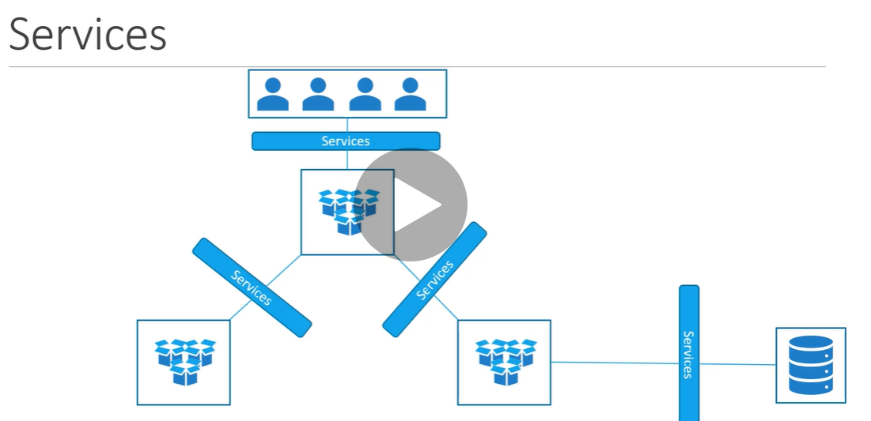

Kubernetes service is an object just like pod,replica set and deployment

**Use case**: listen to port on node and forward request to port on pod to run web application this type of service is called **node port** service

Types of service:

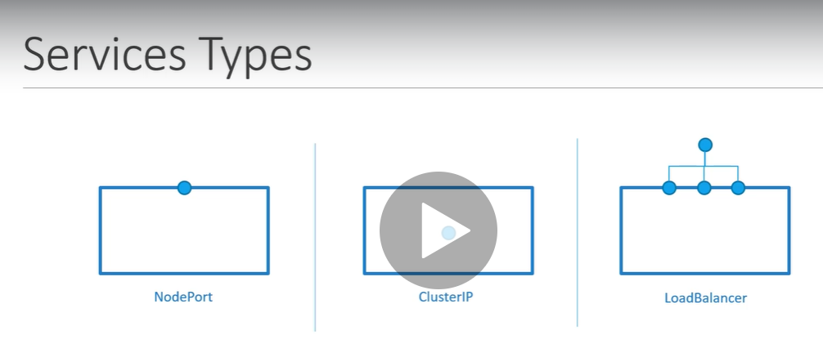

A **NodePort** is an open port on every node of your cluster. **Kubernetes** transparently routes incoming traffic on the **NodePort** to your service, even if your application is running on a different node

**Nodeport**: where service make an internal pod accessible on the port on the node

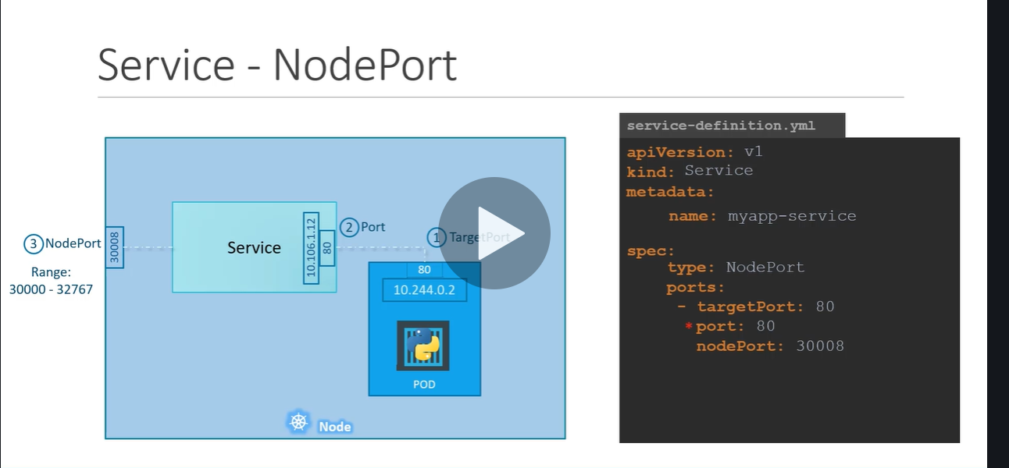

We need to provide selector : label so that it will map for which pod we need to create

Clusterip: service create a virtual ip inside the cluster to enable communication between diff services such as front end backened

Put label in selector section this will link service to pod

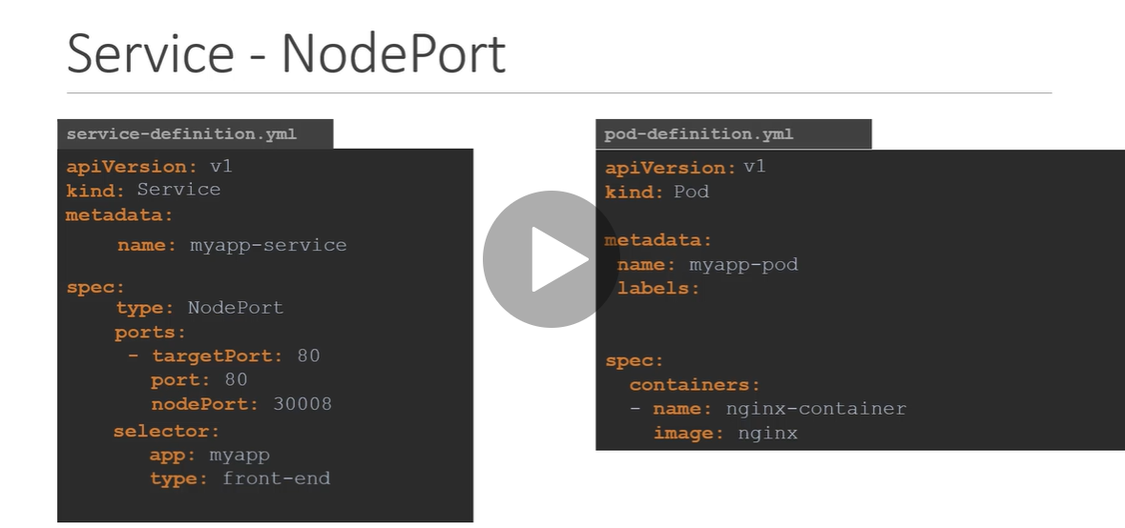

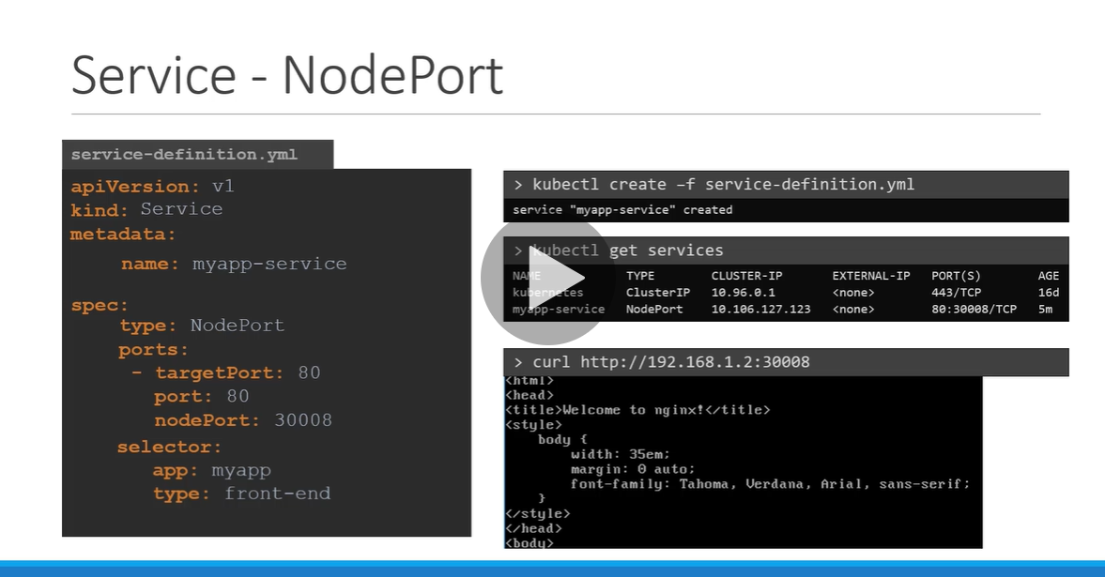

**We can access it :** Ip of the node:port

NOTE:

So far we discussed when service is mapped with single pod but what will happen when multiple pod is there

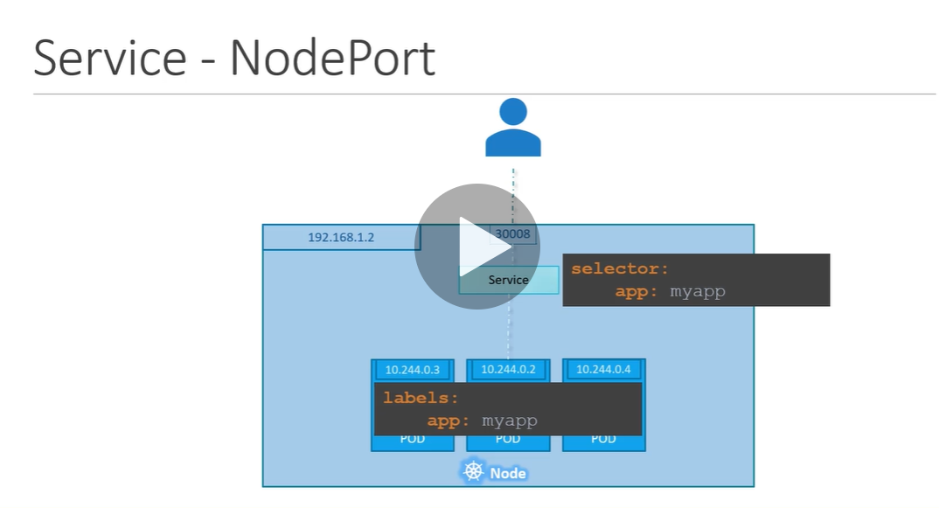

Note when multiple pod is there service will match label and it will forward external request to all the pod coming from the user we don’t have to do any additional configuration.

Note: IT USES RANDOM ALGORITHM

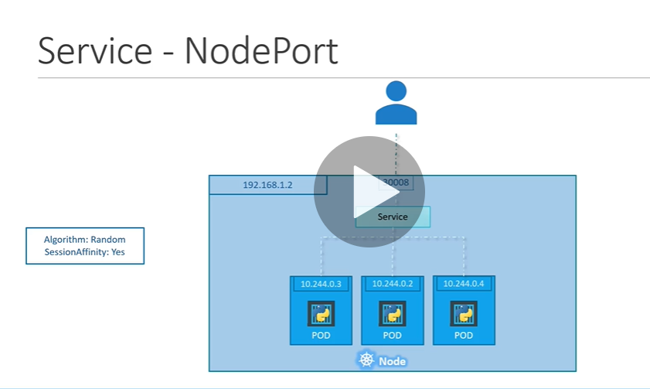

NOTE : what will happen when pod are distributed across multiple node

Kubernetes service will expand across all node and we don’t need to do any additional configuration

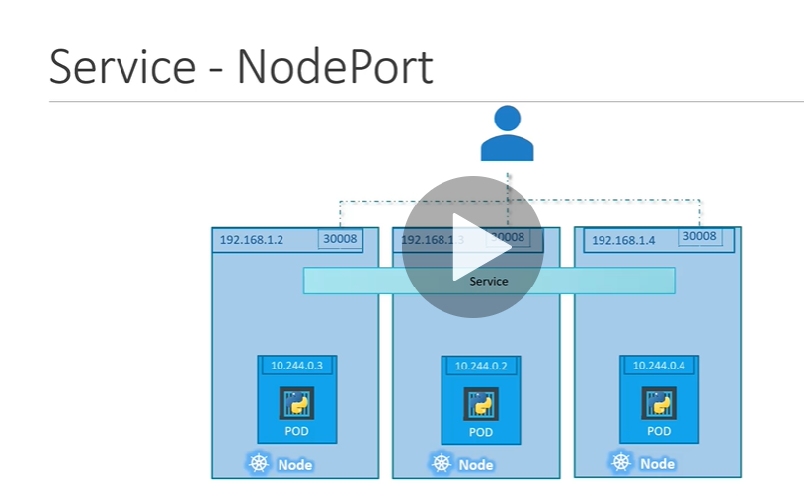

**Same port is available across all the node**

When pod is created or deleted service automatically updated

Cluster ip

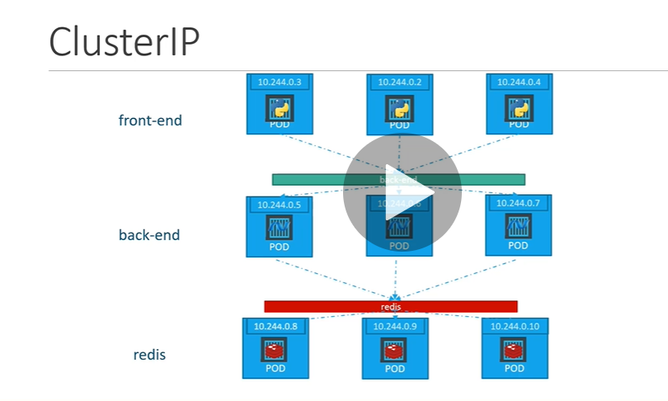

Clusterip is default ip

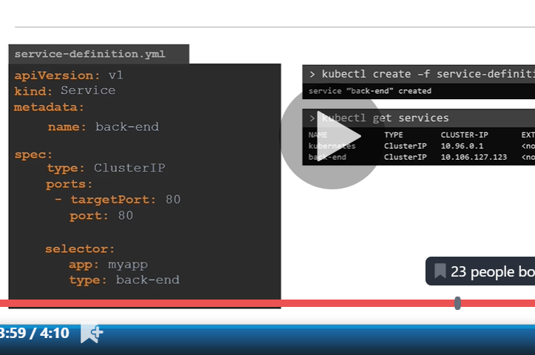

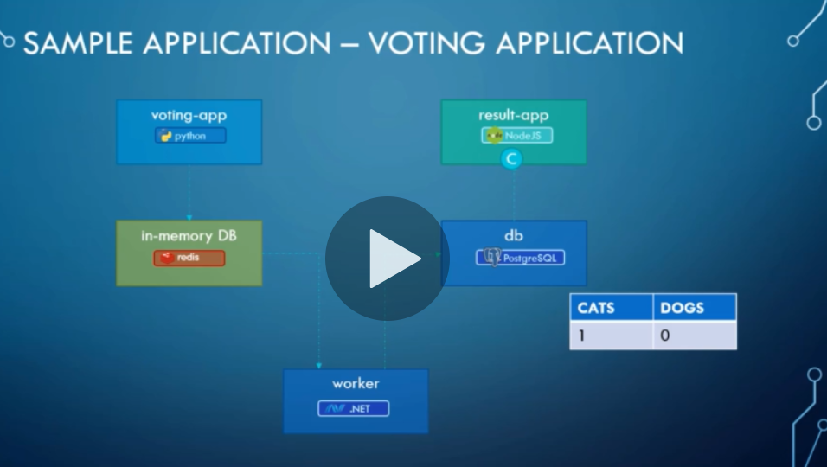

Note: loadbalancer service work on aws and google cloud plateform

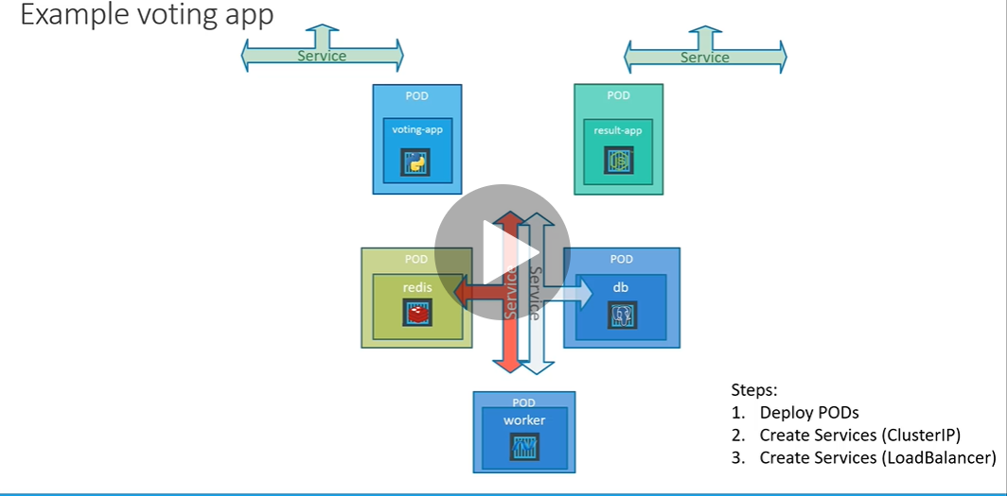

=========================================================================================

Namespaces:

Each name will use a certain amount

**Namespaces** are a way to divide cluster resources between multiple users (via resource quota). In future versions of **Kubernetes**, objects in the same **namespace** will have the same access control policies by default

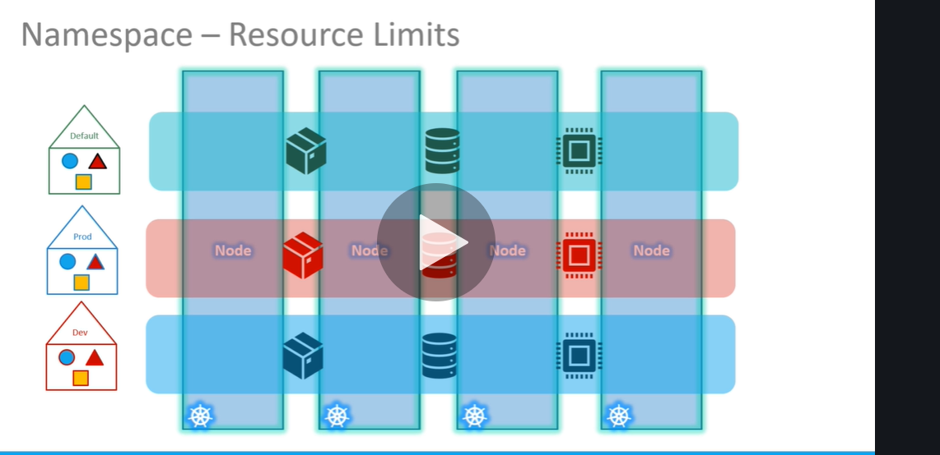

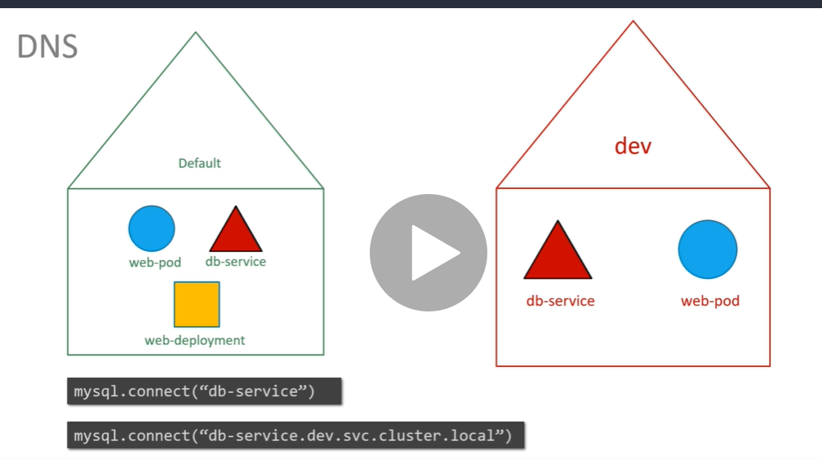

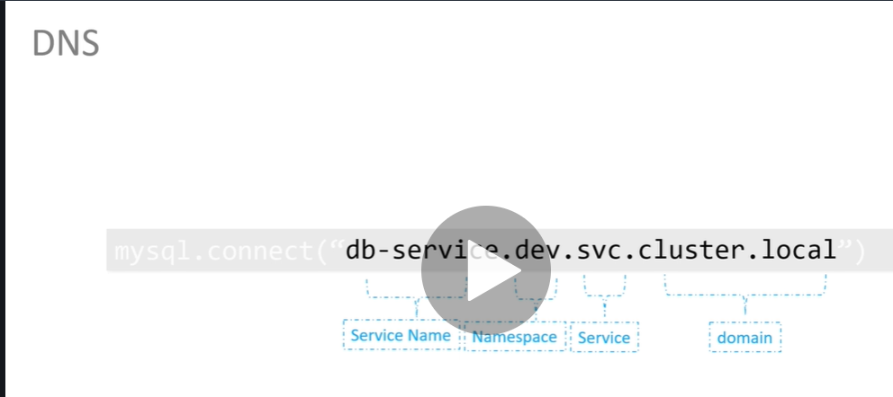

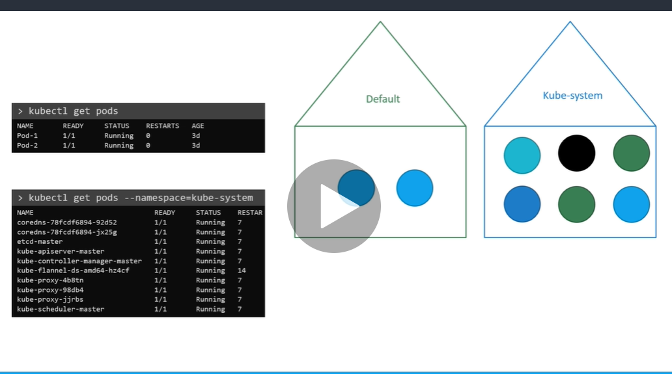

Kubectl get pods :--- will search in default namespace

We can give namespace in command line also

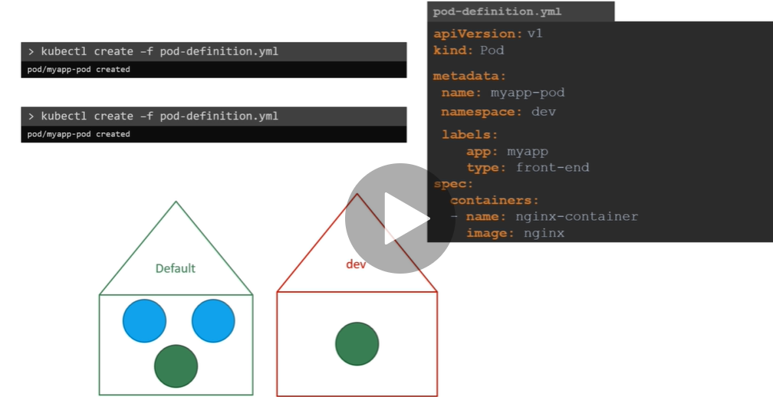

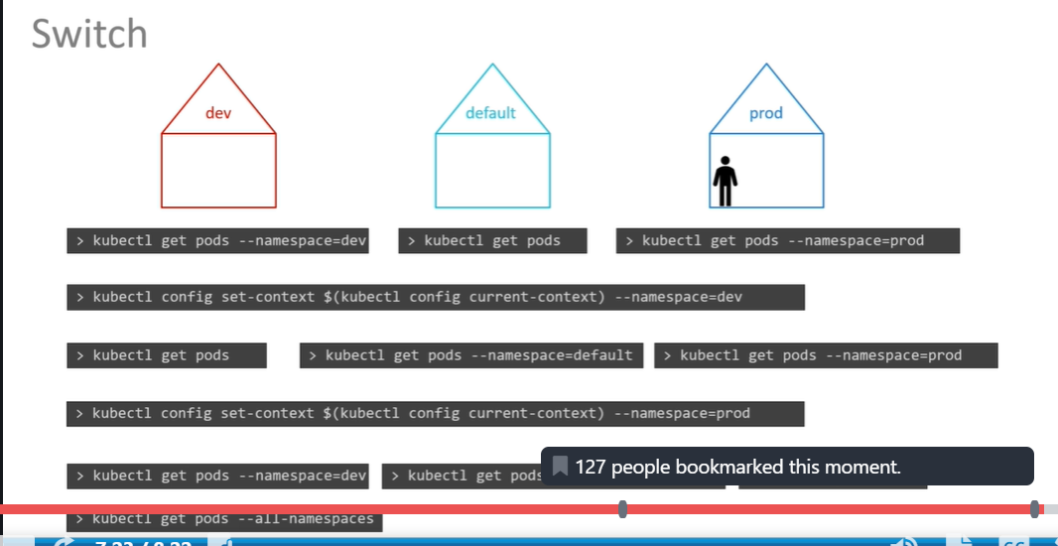

**====================================================**

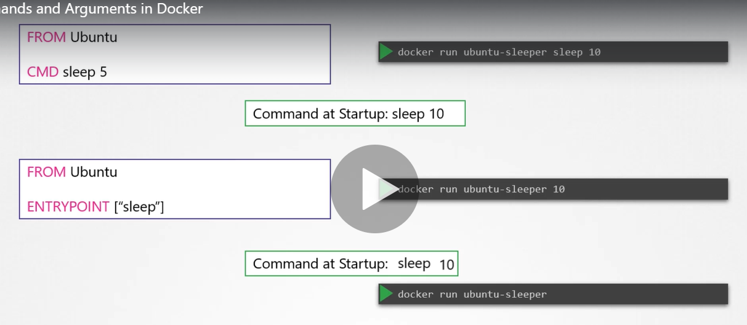

In case of cmd the command line parameter get replace by cmd

While in case of entrypoint the command line parameter ge appended

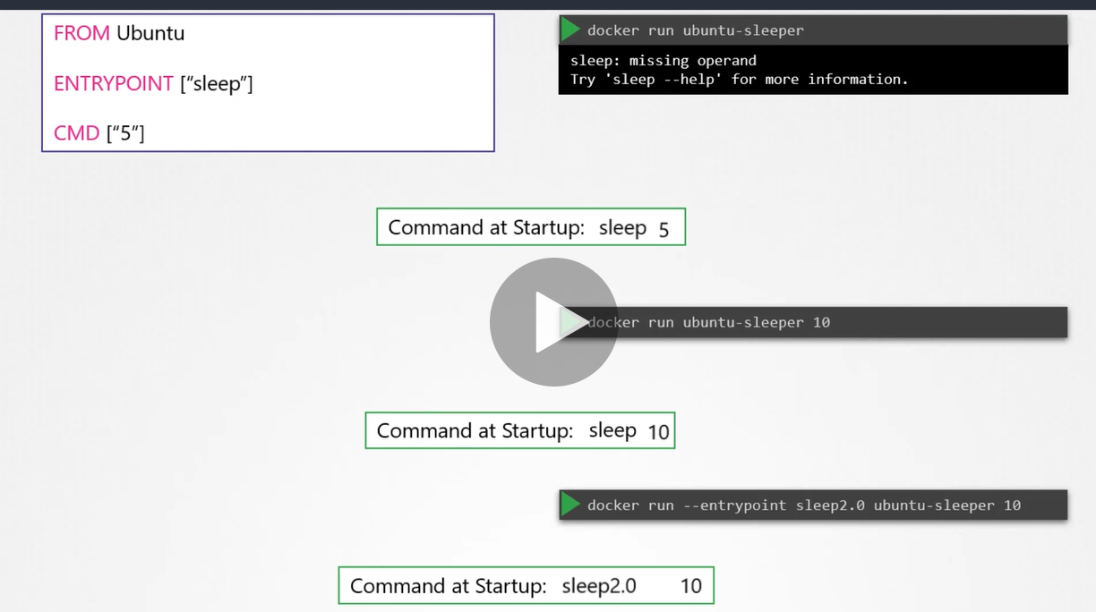

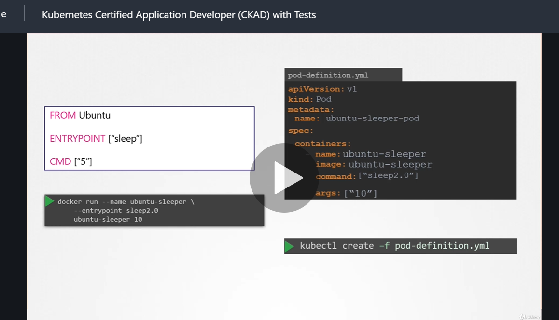

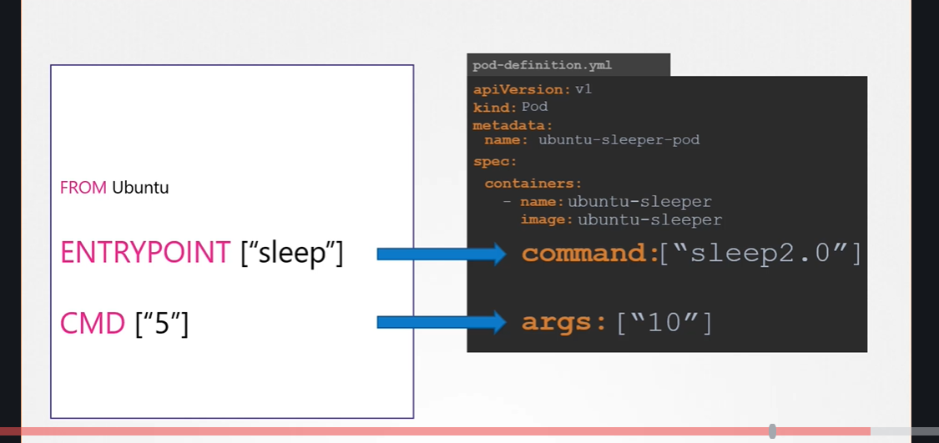

Command field is entrypoint in pod-definition file and cmd is args

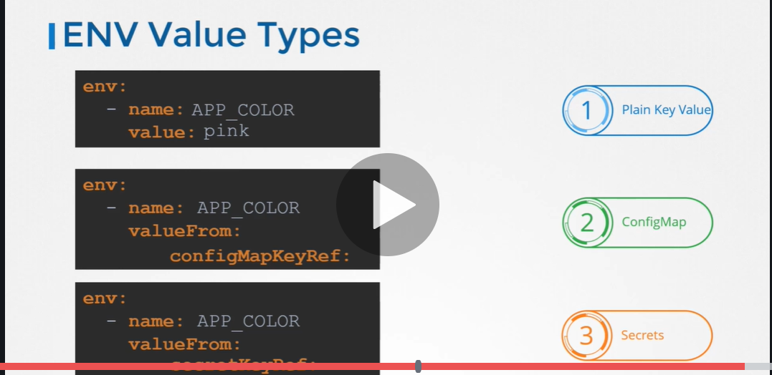

Configure env variable in config map

**Two steps involved in config map**

* 1. **Create config map**
  2. **Inject in pod.yml**

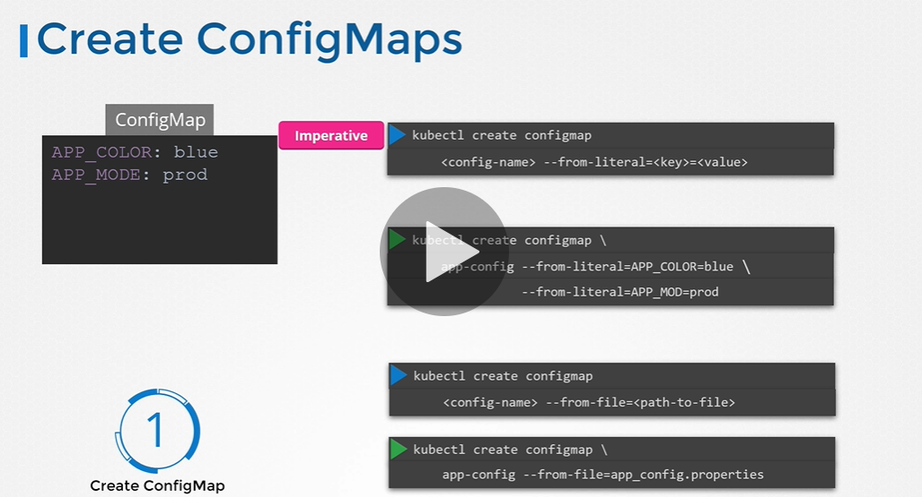

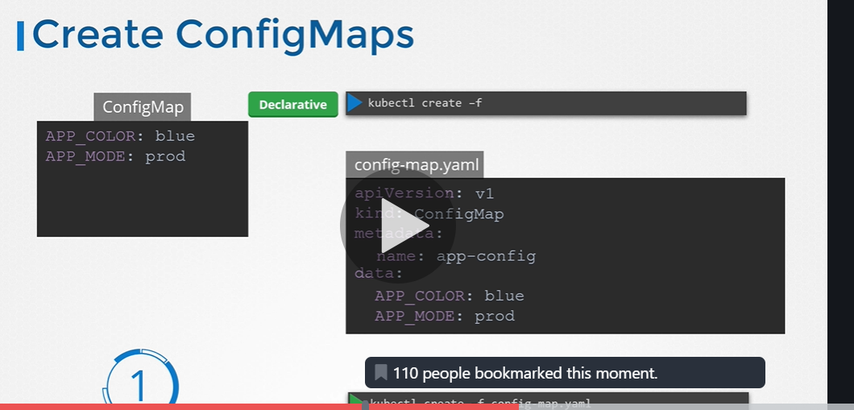

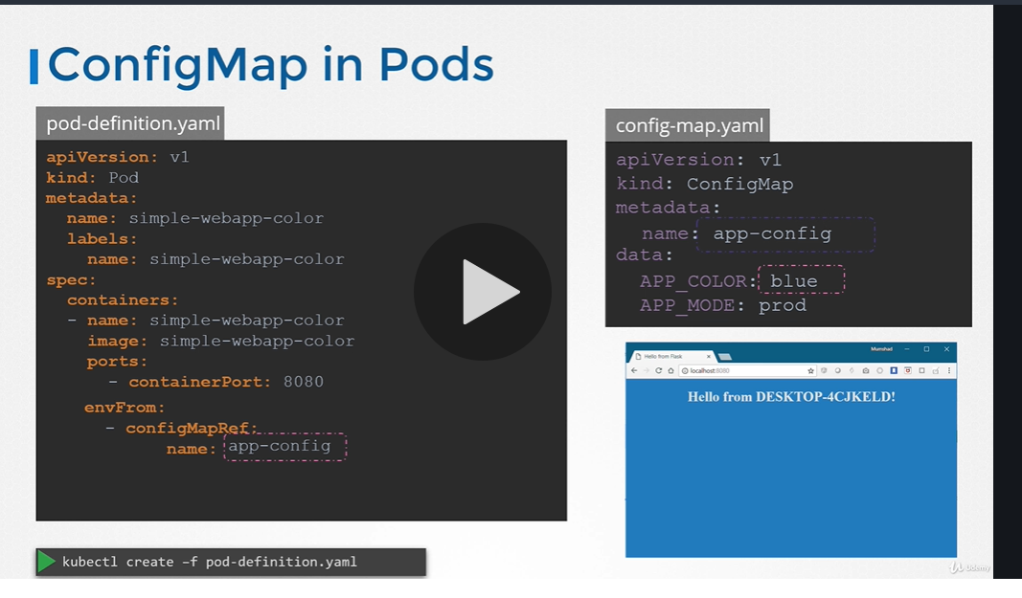

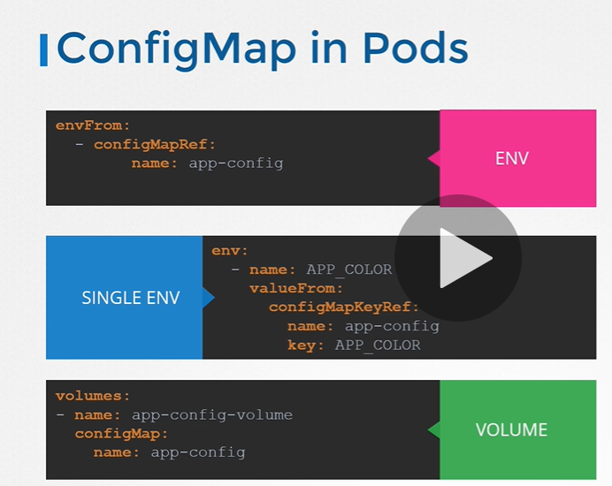

The major **difference** is, **Secrets** store data in base64 format meanwhile **ConfigMaps** store data **in a** plain text. If you have some critical data like, keys, passwords, service accounts credentials, db connection string, etc then you should always go for **Secrets** rather than Configs

Secret use for sensitive data:

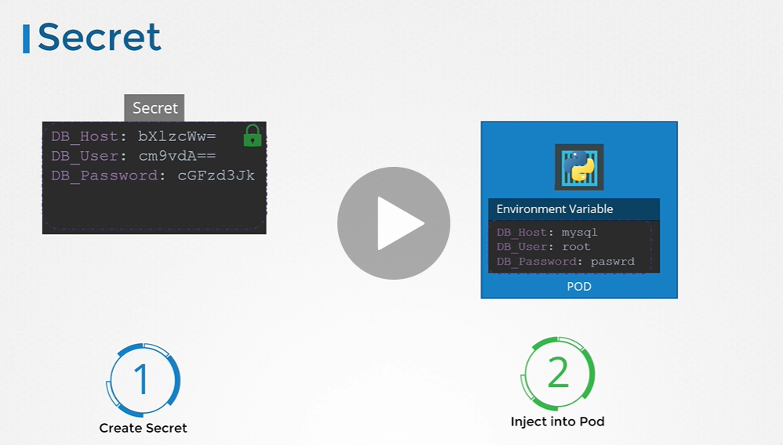

* 1. **Create a secret**
  2. **Inject into pod**

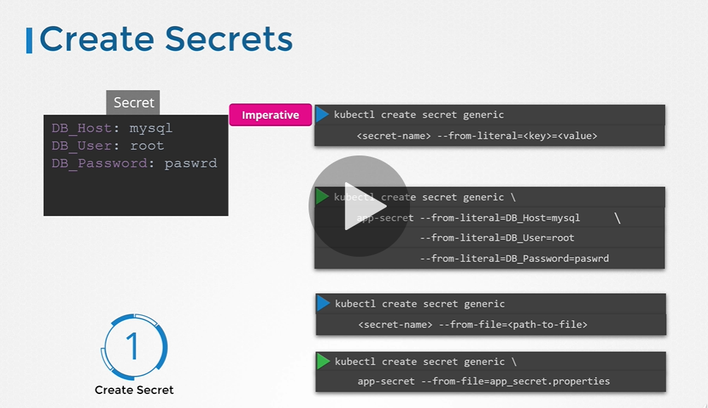

**Note in secret the data should be in encoded form but how to convert data from plain text to encoded form**

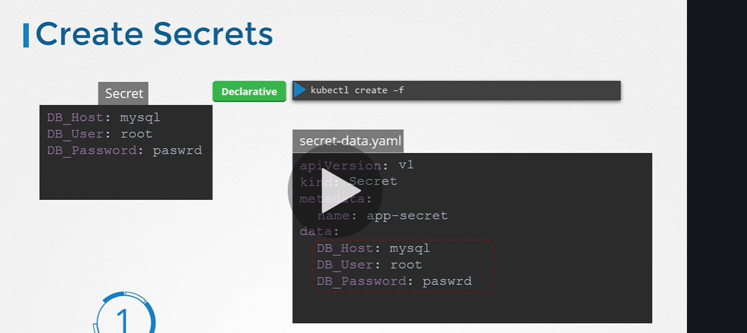

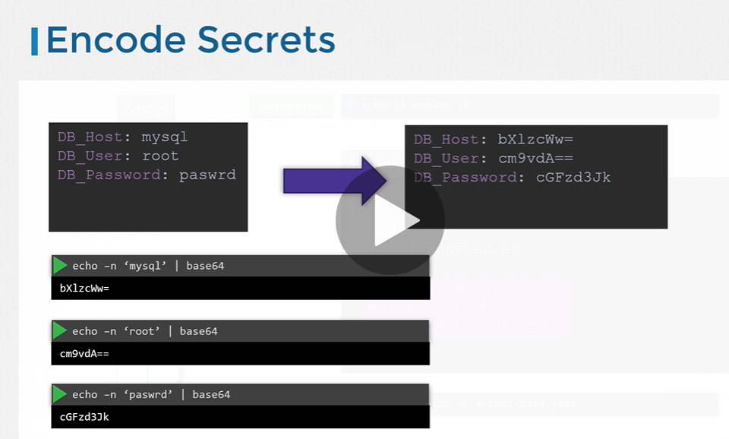

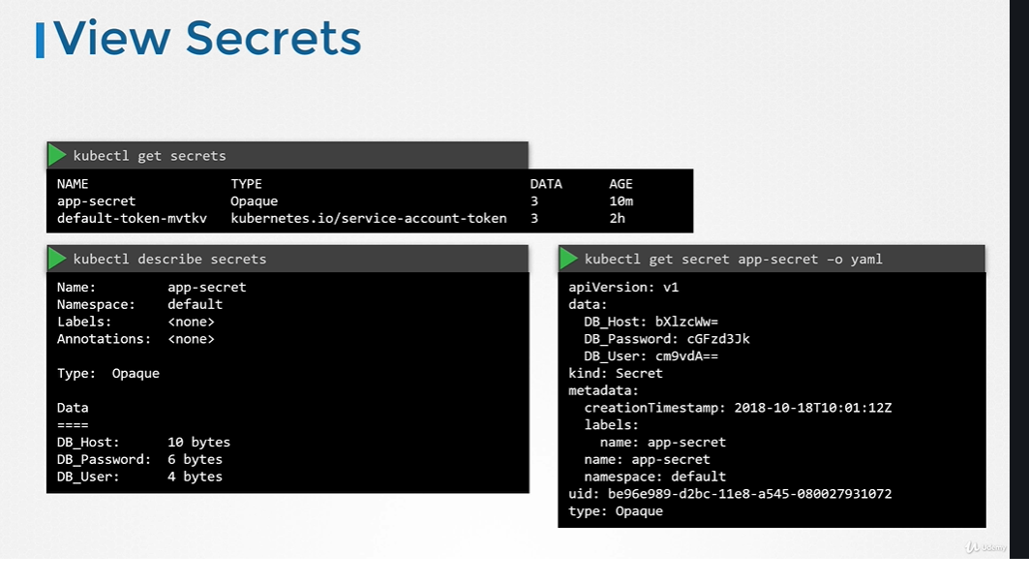

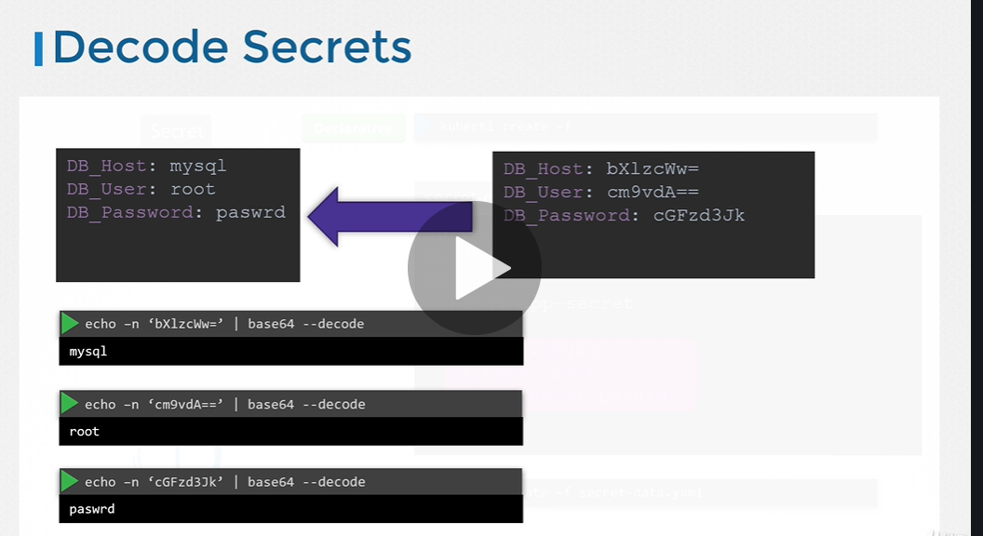

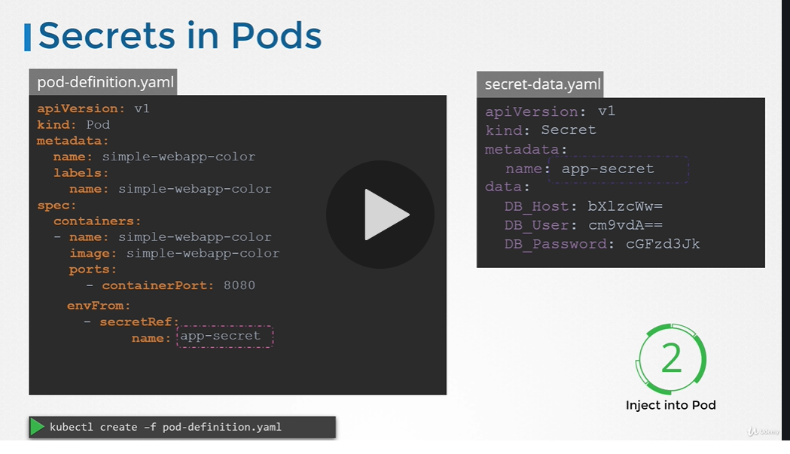

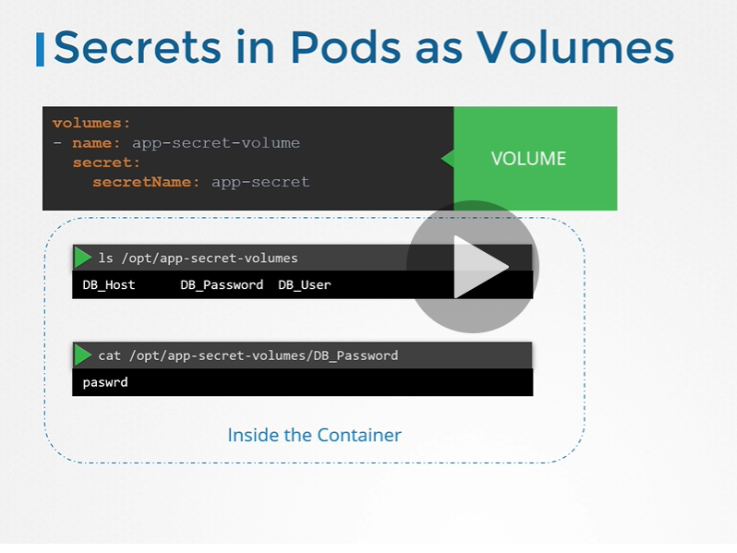

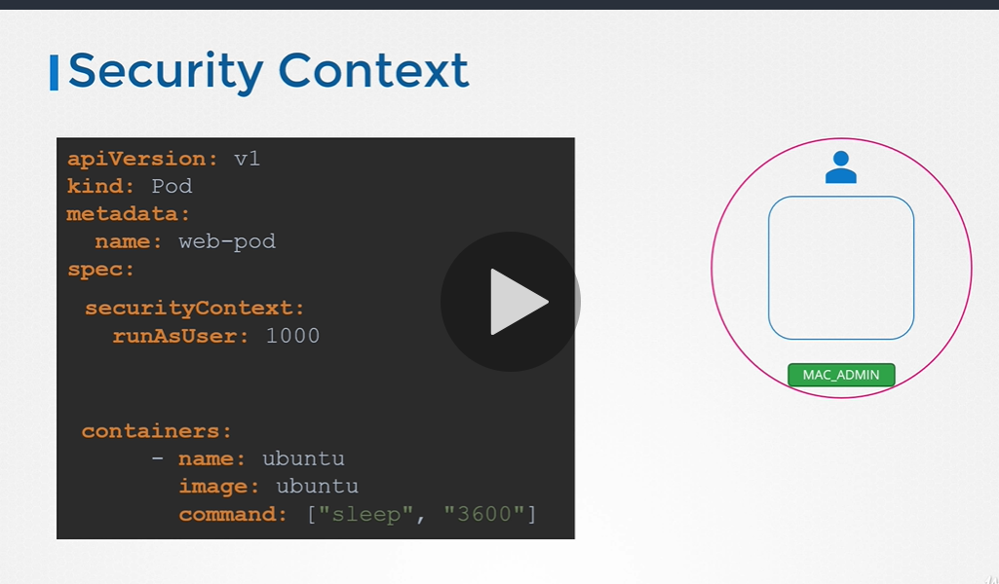

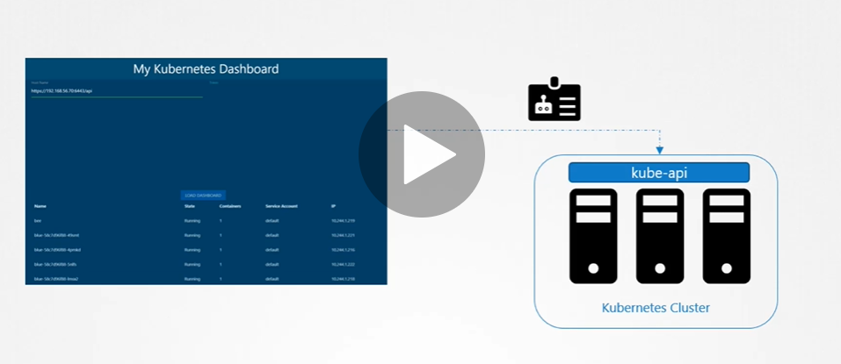

**NOTE: in order to connect dashboard to kubernetes cluster It has to be authenticated and it will use service account.**

**NOTE: when serviceaccount( use by machine) is created it also create a token and it creates a secret object and it linked to service account**

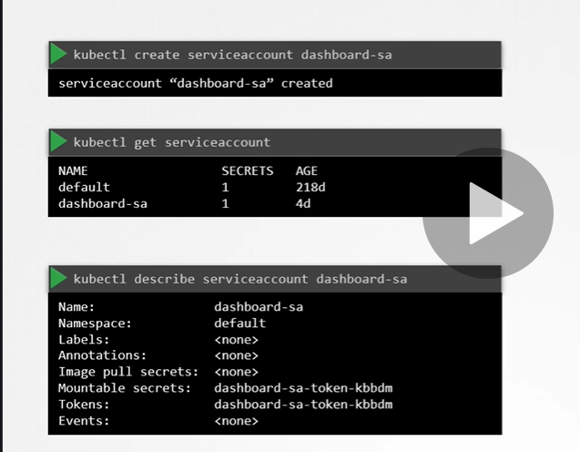

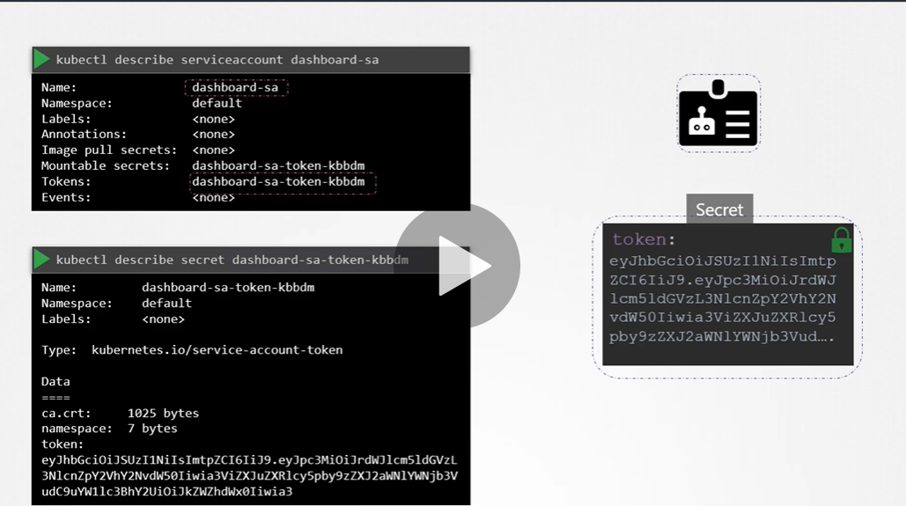

**If third party like prometheus is already installed in kuernetes the secret can be mout as volumes in pods**

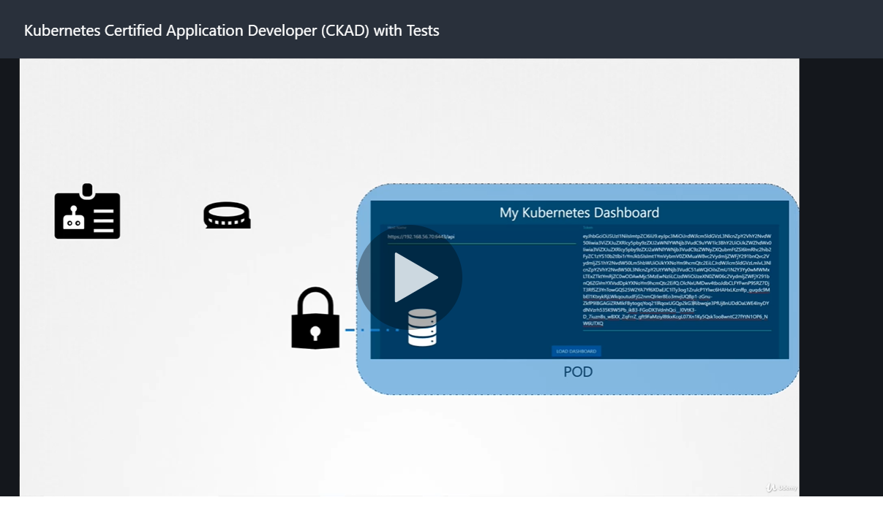

**NOTE: each namespace has own default service account**

Whenever we created pod service account is already created

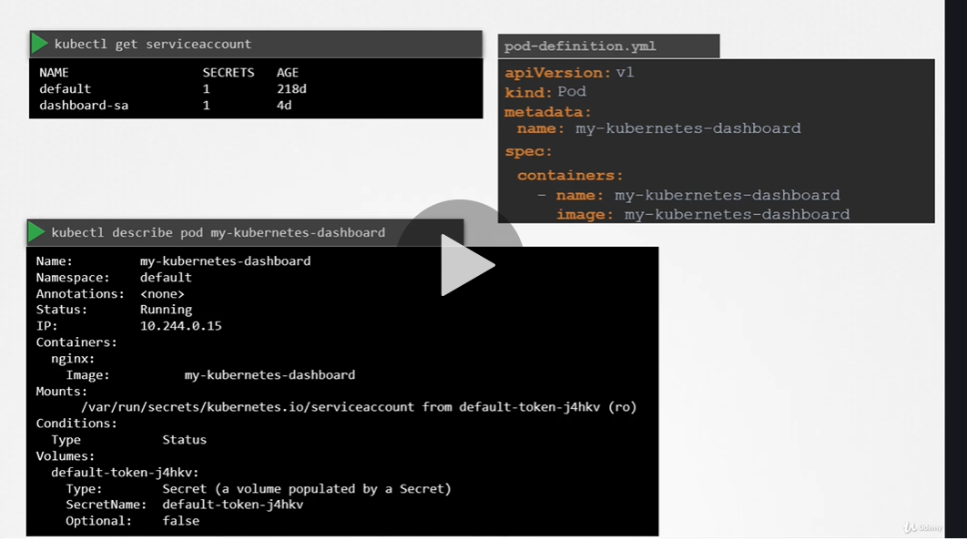

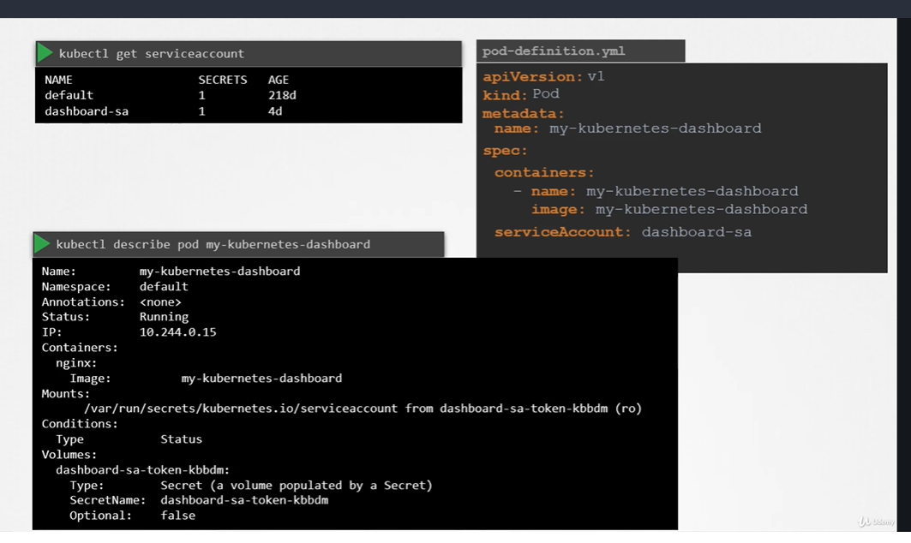

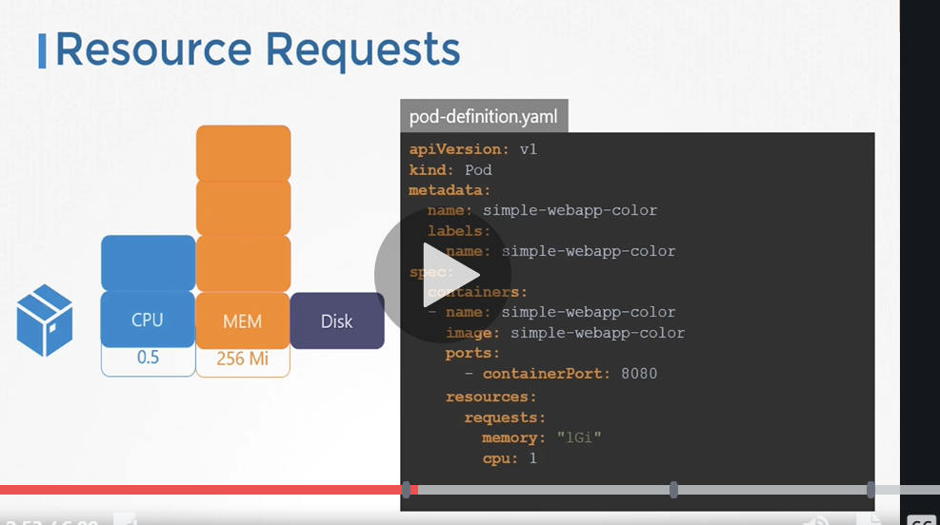

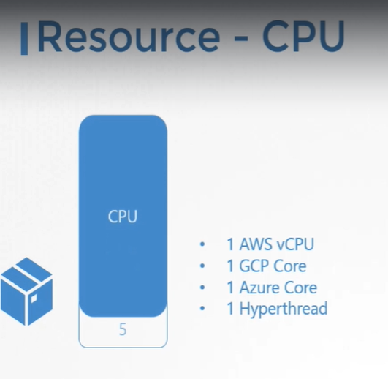

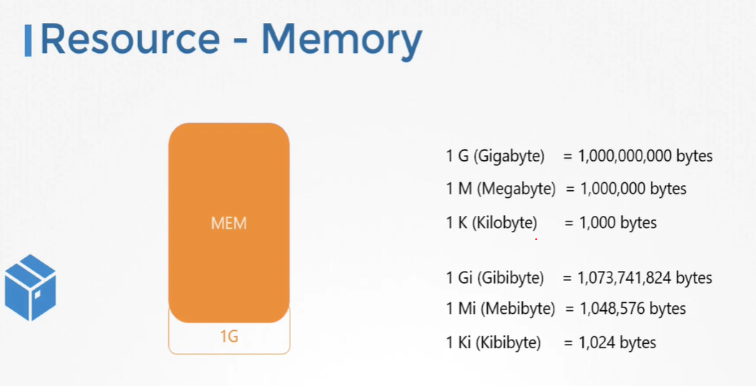

NOTE: a container cannot use more cpu than it limit but it can use more memory than it limit

Multi container pod

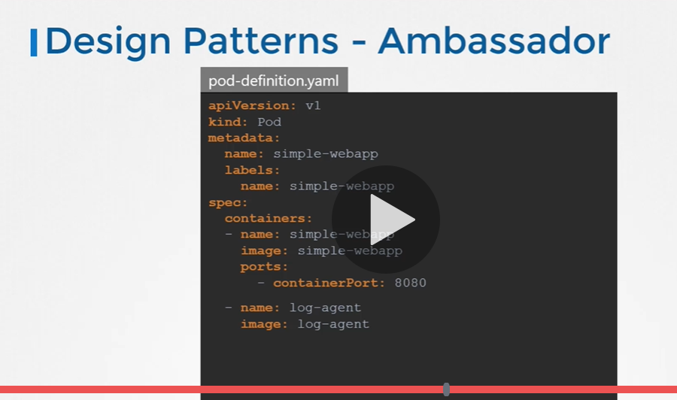

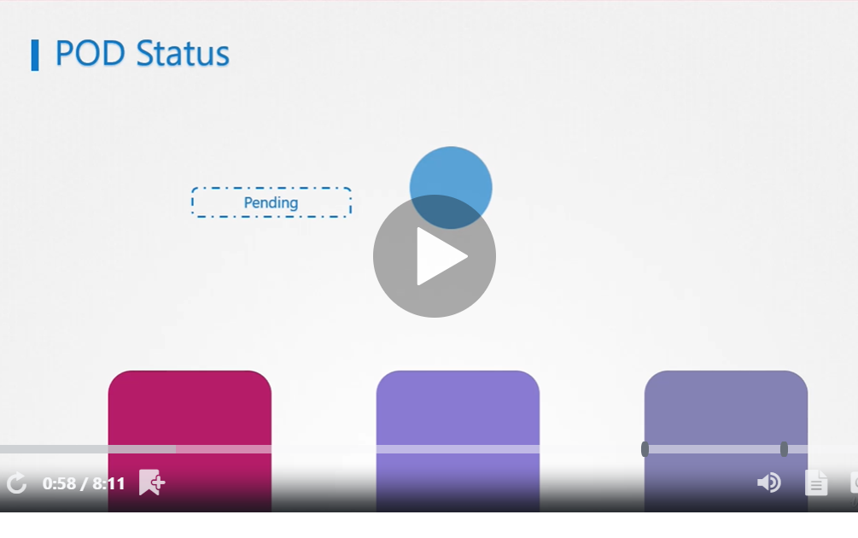

POD STATUS: pending means scheduler try to find out where to keep pod in node

to find out why it is in pending state run kubectl describe pods

* 1. Running:-

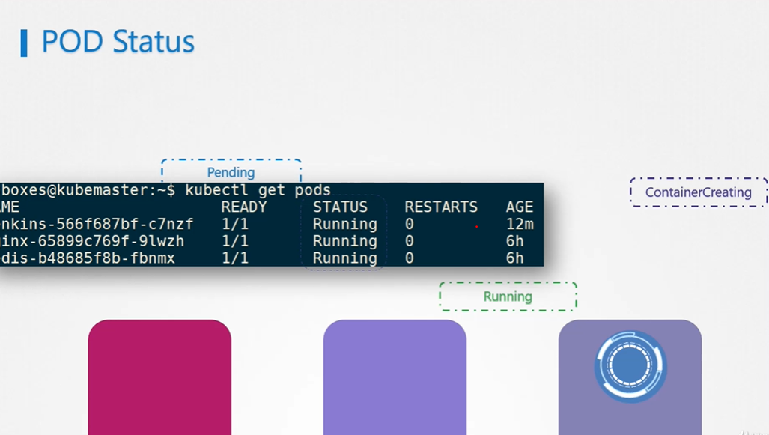

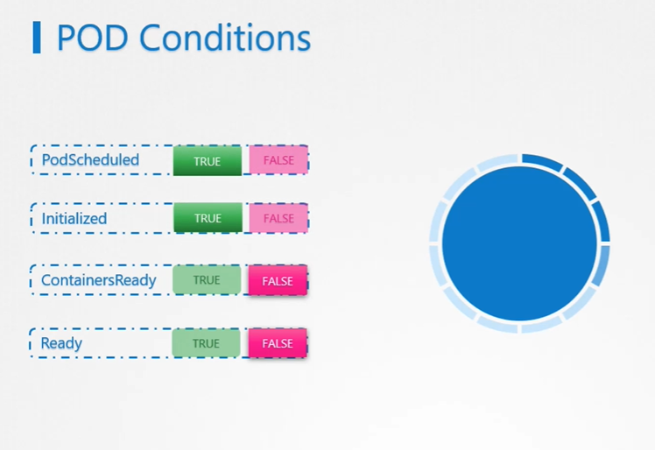

NOTE: kuberetes does not make pod in ready state until it perform test and test is pass then it is in ready state and service will route traffic to pod

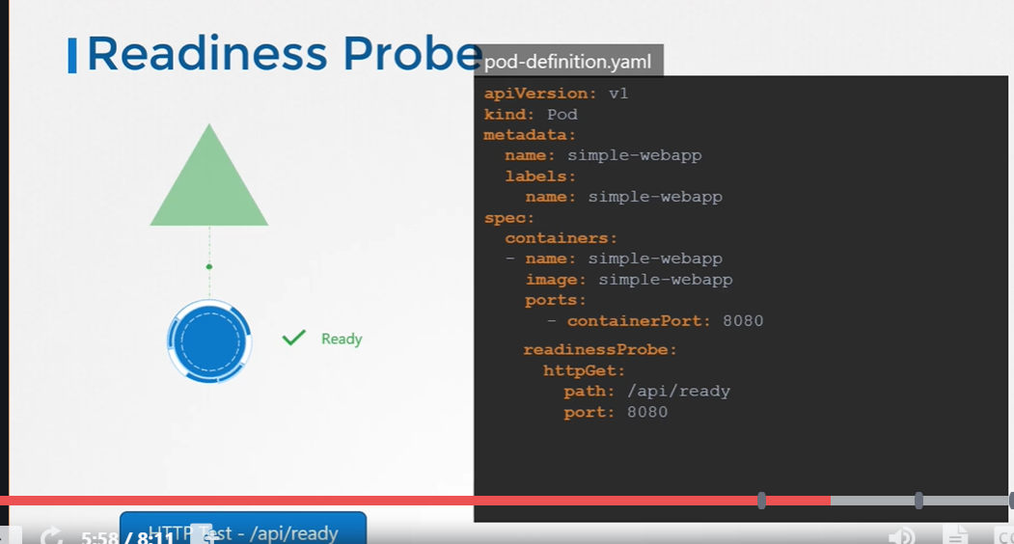

Liveness probe : can be configured on container to periodically test whether our application is up or not

If not it will create container

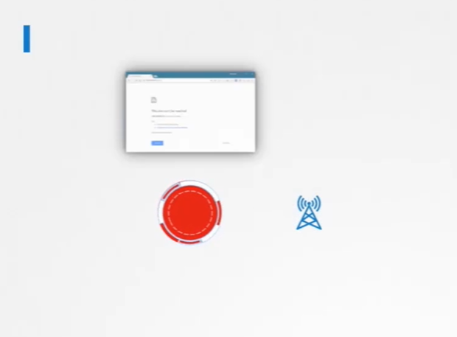

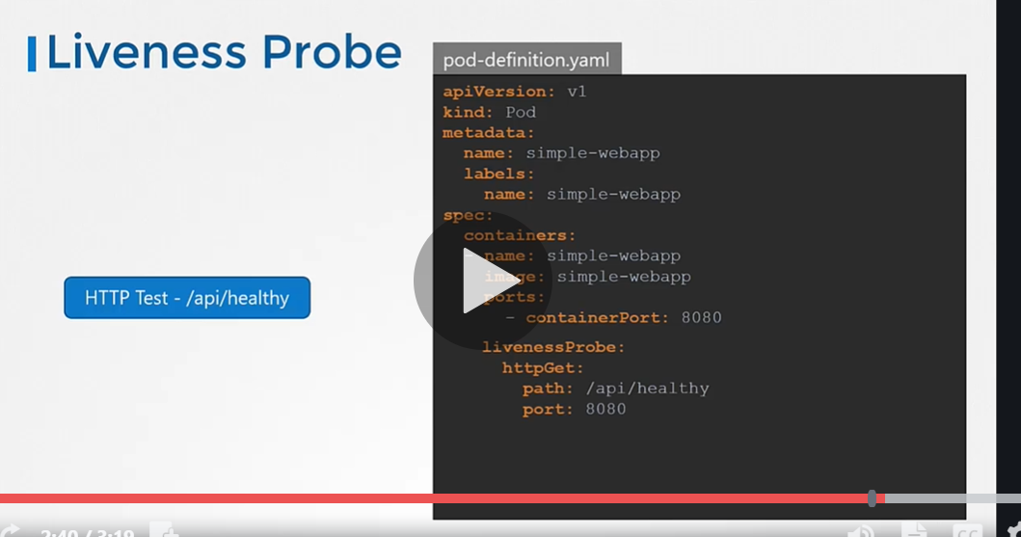

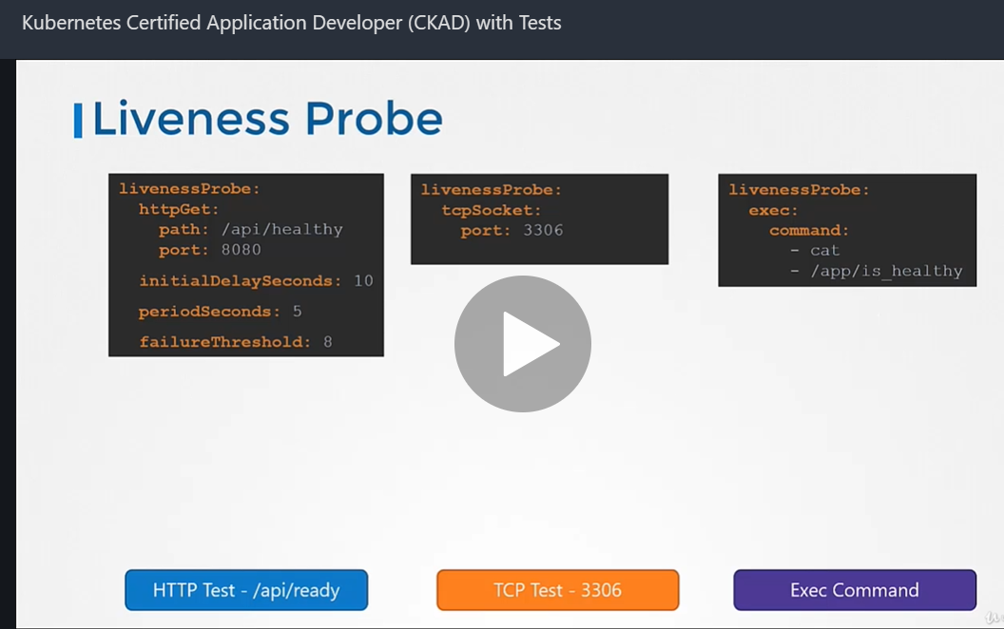

Kubernetes **Liveness and Readiness Probes**. Kubernetes uses **liveness probes** to know when to restart a container. ... Kubernetes uses **readiness probes** to decide when the container is available for accepting traffic. The **readiness probe** is used to control which pods are used as the backends for a service

**To see logs in docker**

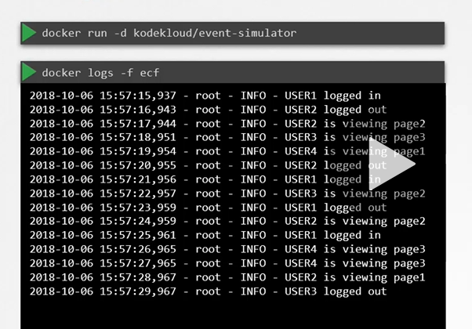

-f ( help to see live log) docker logs -f container id

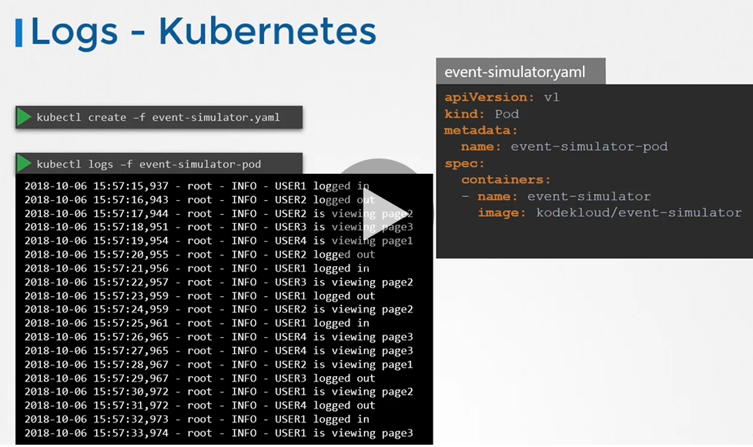

If multiple container are there we need to give name of the container also

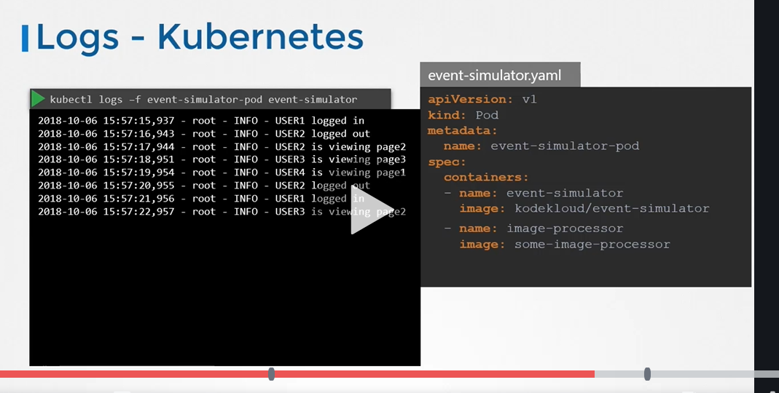

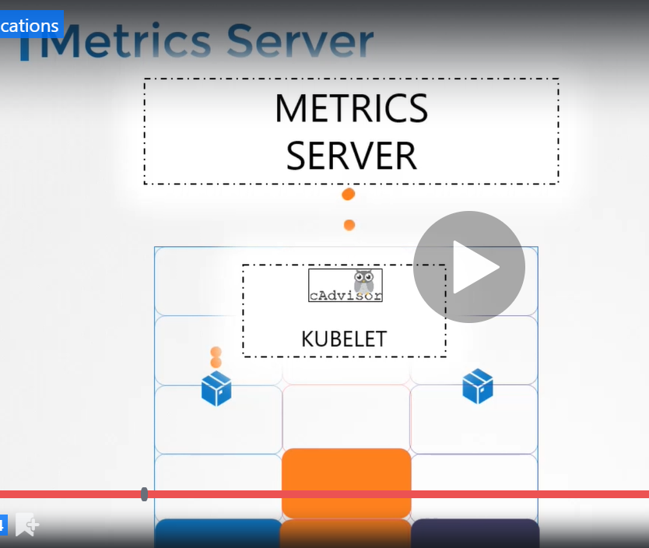

**cAdvisor** (Container Advisor) provides container users an understanding of the resource usage and performance characteristics of their running containers. It is a running daemon that collects, aggregates, processes, and exports information about running containers.

Cadvisor is component of kubelet

**POD DESIGN**

Labels are property attached to each item

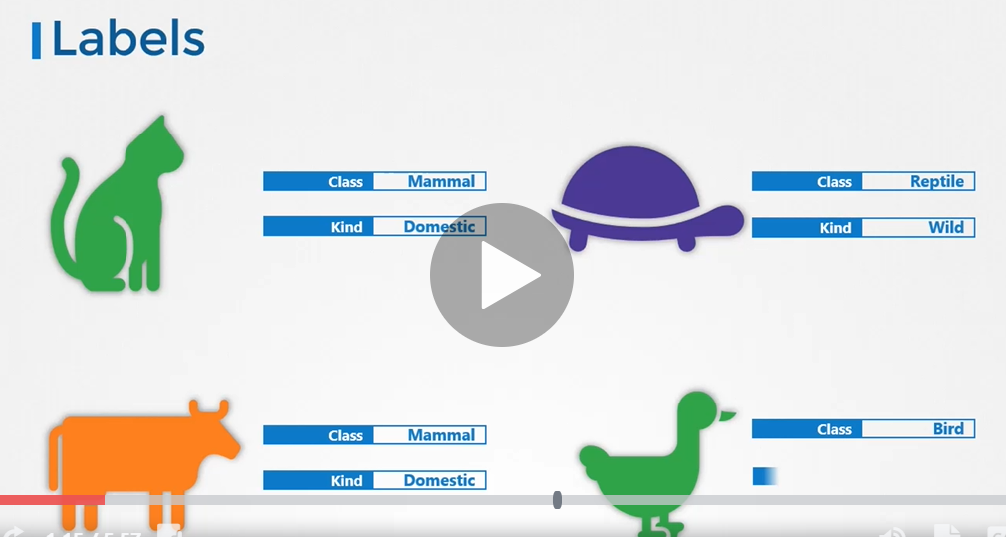

**Selector are use to filter**

**Group object by their type**

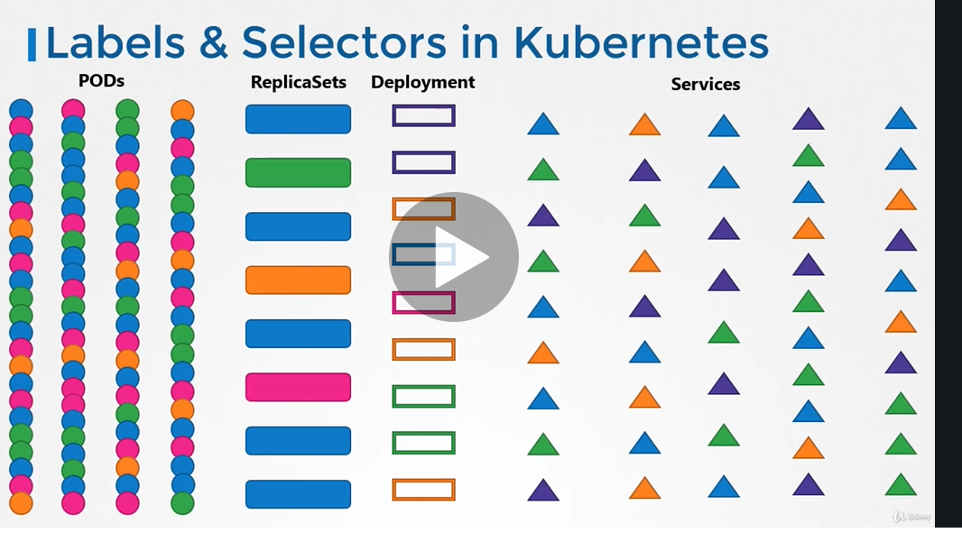

**View object by application**

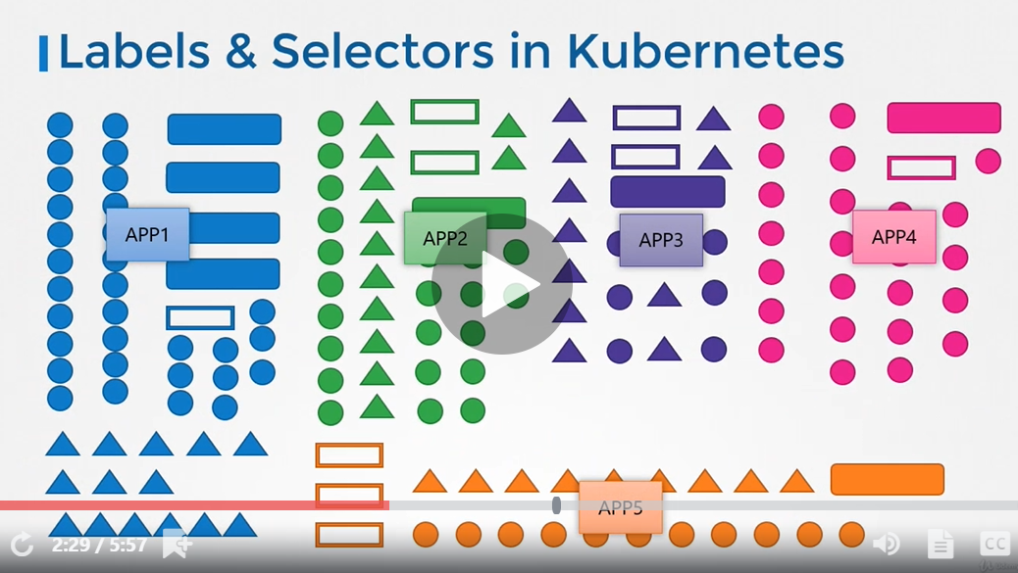

**By their functionality**

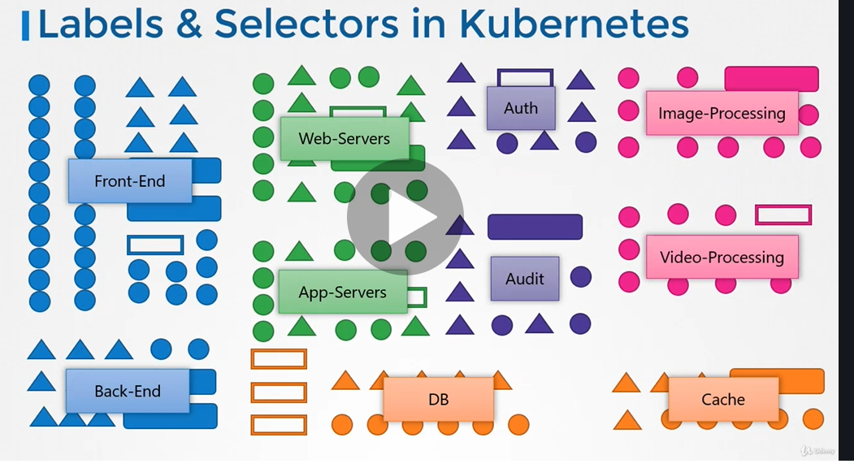

**For each object attach label as per needs**

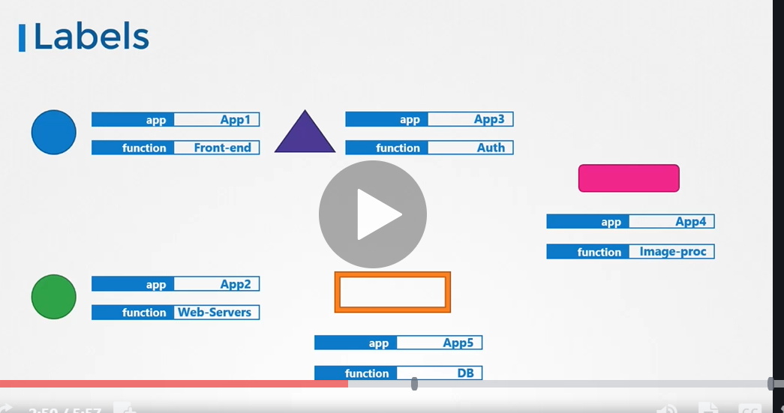

**Use case**

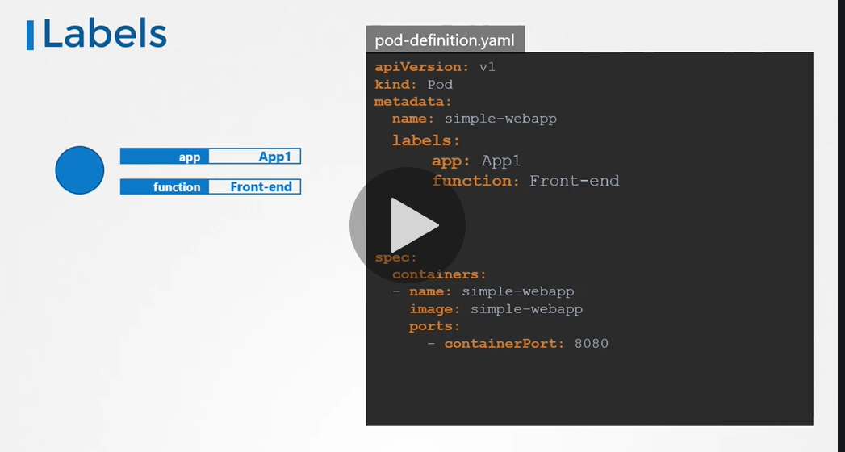

**Once the label is create we can use selector to filter**

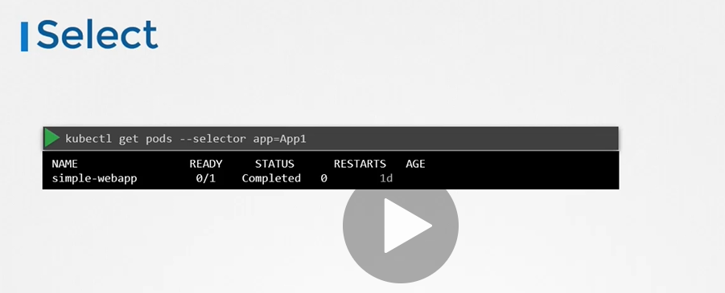

**NOTE: the labels defined under replica set are label defined in pods**

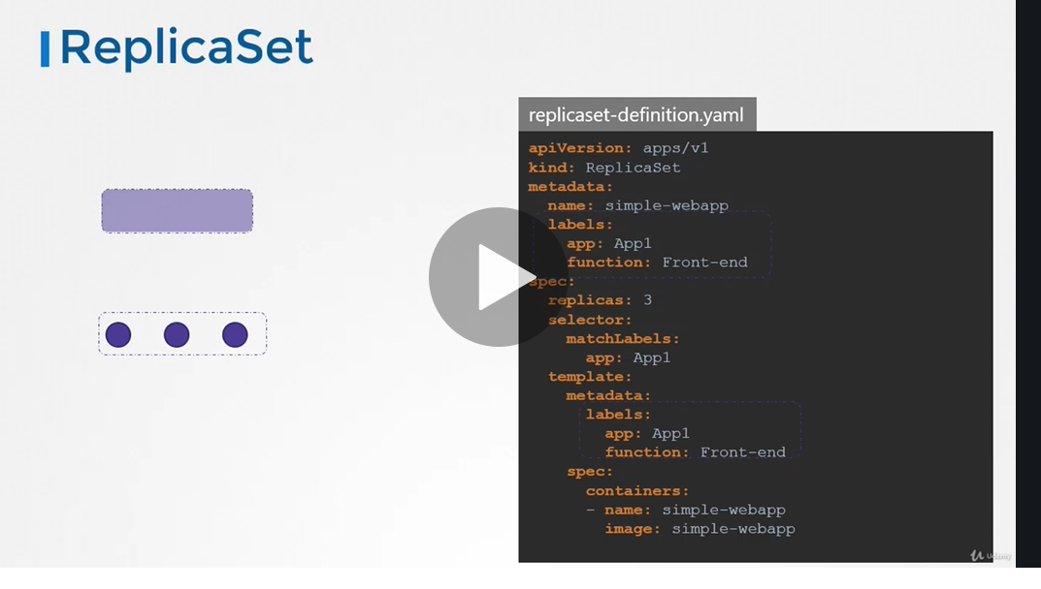

**Annotation are use for phone ,email etc.**

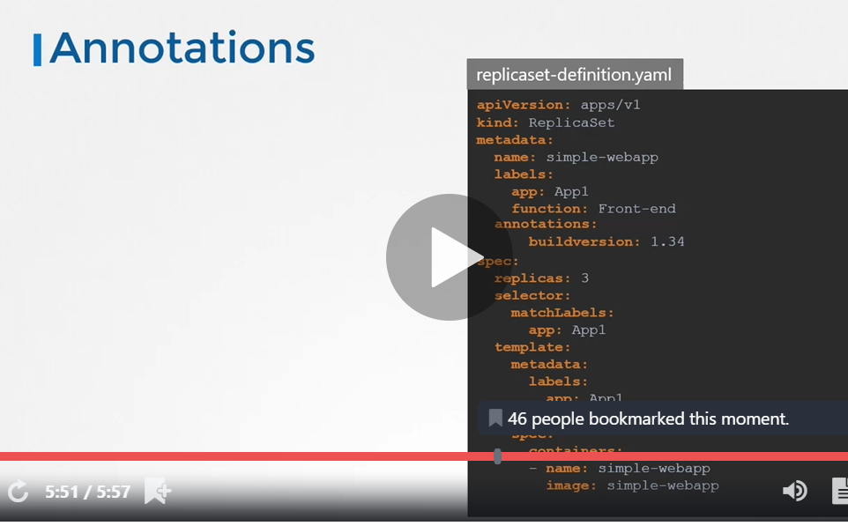

restartPolicy: Always means ( container will start always once job is over)

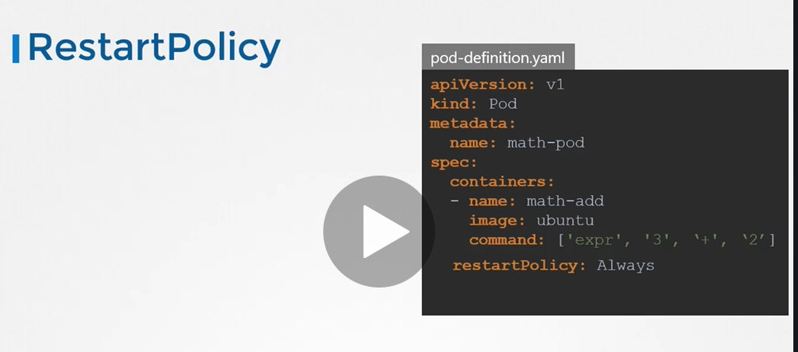

restartPolicy: never

Kubernetes does not start container once job is finish

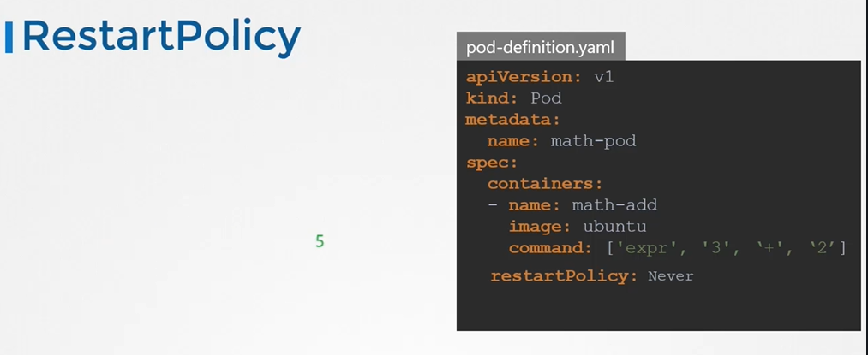

Jobs

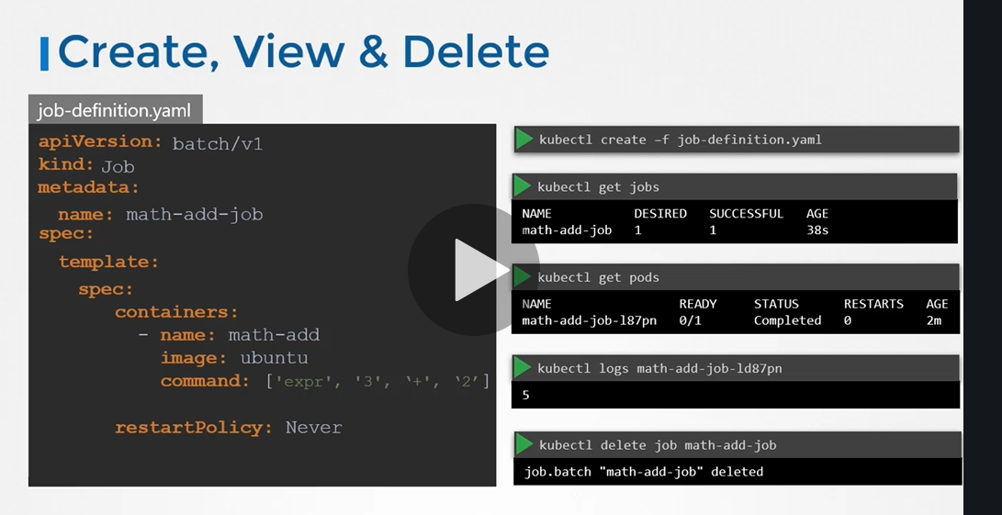

A **job in Kubernetes** is a supervisor for pods carrying out batch processes, that is, a process that runs for a certain time to completion, for example a calculation or a backup operation.

It will create job parellely

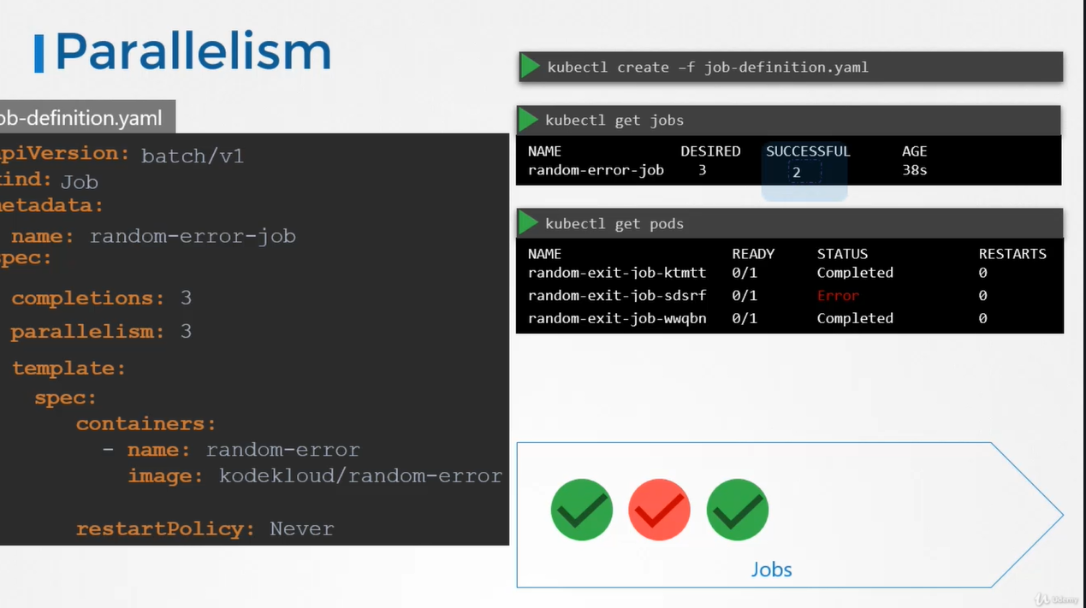

Job will run again until it get 3 success complete

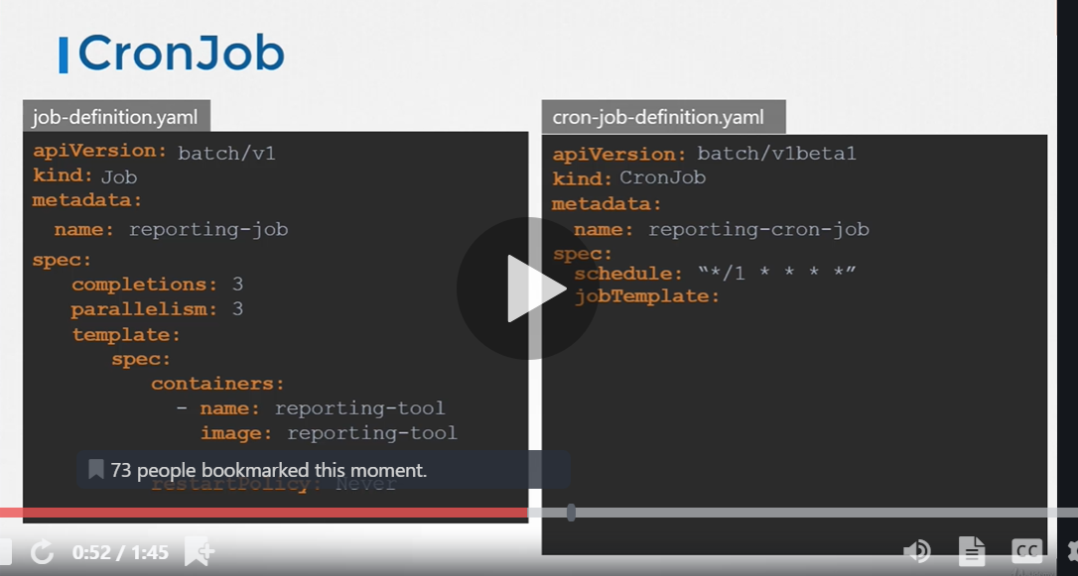

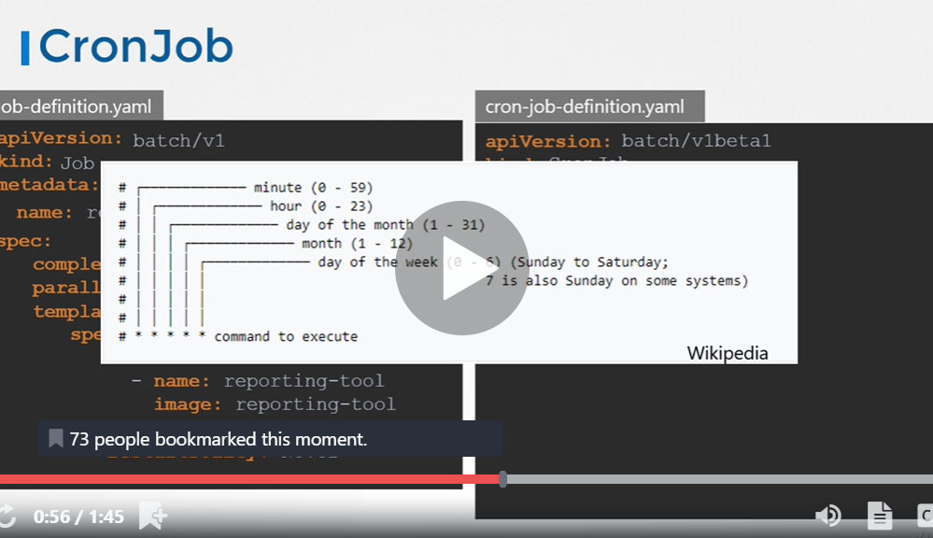

Three spec section one for the cron job, one for job, one for pod

